CS161: Notes

# Midterm (5/6/2024)

Expect about eight questions, most of them have multiple parts. Some of these questions will be true/false. Others will cover the following subjects:

— Ordering nodes in search trees according to expansion by various search strategies

— Properties of various search strategies

— Evaluating game trees using minimax

— Pruning game trees using alpha-beta pruning

— Proving entailment using truth tables and using resolution

— Normal forms

This list is NOT exhaustive but should help you focus your studies.

Week 1

L1. Introduction to artificial intelligence and course subjects. Chapters 1-2.

L2. Problem solving as search. Chapter 3.

Week 2

L3. Systematic search strategies. Chapter 3.

L4. Informed search strategies, local search. Chapters 3, 4.

Week 3

L5. Constraint satisfaction. Chapter 6.

L6. Game playing and adversarial search. Chapter 5.

Week 4

L7. Propositional logic: Representation. Chapter 7.

L8. Propositional logic: Inference I. Chapter 7.

Week 5

L9. Propositional logic: Inference II. Chapter 7.

L10. First-order logic: Representation. Chapter 8.

# 4/1/2024

*Went over intro slides in class*

# 4/3/2024

***Formatting issues when I change the font so will fix later***

1. Problem solving using search (algo nature)  
   → Knowledge representation and Reasoning
2. Symbolic (Logic)
3. Numeric (probability)
4. Machine Learning

“Problem” → search formulation → search engine → solution

^

|

Search strategy

* blind/unformed
* Heuristic/informed

1. Initial state
2. Final state
3. Actions
4. Heuristic

* 1, 2 ,3 are part of search formulation
* Search engine involves creating search tree

Constraint satisfaction problems (CSPs)

8 puzzle:

The constraints in the 8-puzzle problem are:

* Movement Constraint: A tile can only be moved into the empty space. This means that in each move, a tile that is adjacent (horizontally or vertically) to the empty space can be swapped with the empty space.
* Boundary Constraint: Tiles cannot move beyond the edges of the 3x3 grid. This limits the movement of tiles to within the confines of the grid layout.
* Goal State: The puzzle is solved when the tiles are arranged in the correct numerical order with the empty space in the correct position (usually at the bottom-right corner of the grid).

**Initial state**

| 7 | 6 | 1 |
| --- | --- | --- |
| 4 | 5 |  |
| 8 | 3 | 2 |

Want to make it into this **Final State** using least possible moves:

| 1 | 2 | 3 |
| --- | --- | --- |
| 8 |  | 4 |
| 7 | 6 | 5 |

**Actions:**

1. To get from the IS to the next one, we can move the blank up, down, left or right

| 7 | 6 | 1 |
| --- | --- | --- |
| 4 | 5 |  |
| 8 | 3 | 2 |

| 7 | 6 | 1 |
| --- | --- | --- |
| 4 | 5 |  |
| 8 | 3 | 2 |

→

Can make a search tree (infinite in general)

IS: 5 4 0 D write matrix/cell numbers when the blank

6 1 8 → is moved down and left

7 3 2 L

From those new matrices, draw arrows for next possible moves (U, D, L, R) and continue till problem is solved

Example: pic

Search strategy:

→ Is it optimal?

Optimal

1. Solution that has an optimal cost
2. Amount of work done by the algo (time/ space)

Non deterministic action:

S0 – a → S1 or S0 – a → S2 So output not always the same/determined

River and Boat → goal: move everyone to the other side of the river using boat

Rules (constraints):

* Boat can take at most 2 creatures
* Cannot have more O creatures than X creatures on any side at any point
* Okay to have all/only Os on one side
* Boat cannot travel empty

→ IS and FS in this example are obvious. There are 5 potential actions (XX, XO, OO, X, O)

* As we have legal states, there are legal actions as well
* After each stage of our action step in the search tree, cross out the illegal ones
* We need to keep track of 3 things: number of Xs on one side, Os on that side, which side boat is on → (a,b,c) where
  + a: # of X on boat side
  + b: # of C on boat side
  + c: boat location {T: right, F: left}

→ Successor function

* Can be used to simplify the actions - instead of providing inputs and analyzing the state every time
* Can just provide the current state and the function will give all the succeeding states to get states from IS to FS
* From this we can find the actions
* Helps us write search engine that is general
* Output would be smth like: [(3,3,T(, (1,1,F).......(3,3,F)]

→ Branching factor - no of legal actions

→ State space - no of possible states

→ Depth of the optimal solution

Constraint Satisfaction (CSP) - goal: put 8 queens on the chess board so that no queen attacks another → No 2 queens in same row, column, diagonal

→ we don’t have a final state, but we have a final state test

→ we want to find the final state that satisfies this test

→ the branching factor gets smaller as we make moves

→ finite search tree depth

Satisfiability (SAT) - goal: find a matching of T or F for each variable such that the constraints are satisfied

* Variables: A, B, C, D, E (boolean)
* Value: T or F
* Constraints:
  + A or not C
  + Not B or D or not E
  + …… etc

* Solving a constraint satisfaction problem on a finite domain is an NP-complete problem in general

* Both these last 2 problems are NP-complete and #P-complete

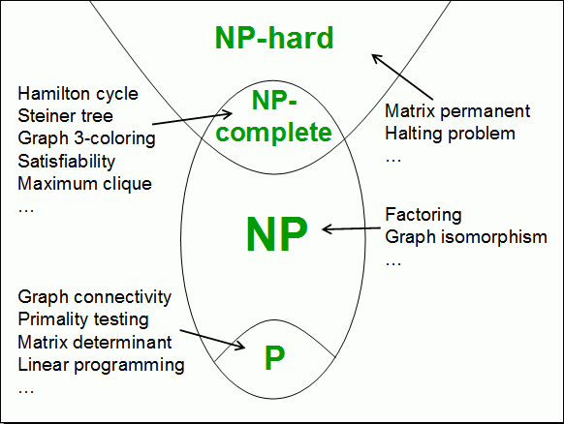

NP hard: which can be solved in non-deterministic polynomial-time → at least as difficult as NP complete but could be harder

# 4/8/2024

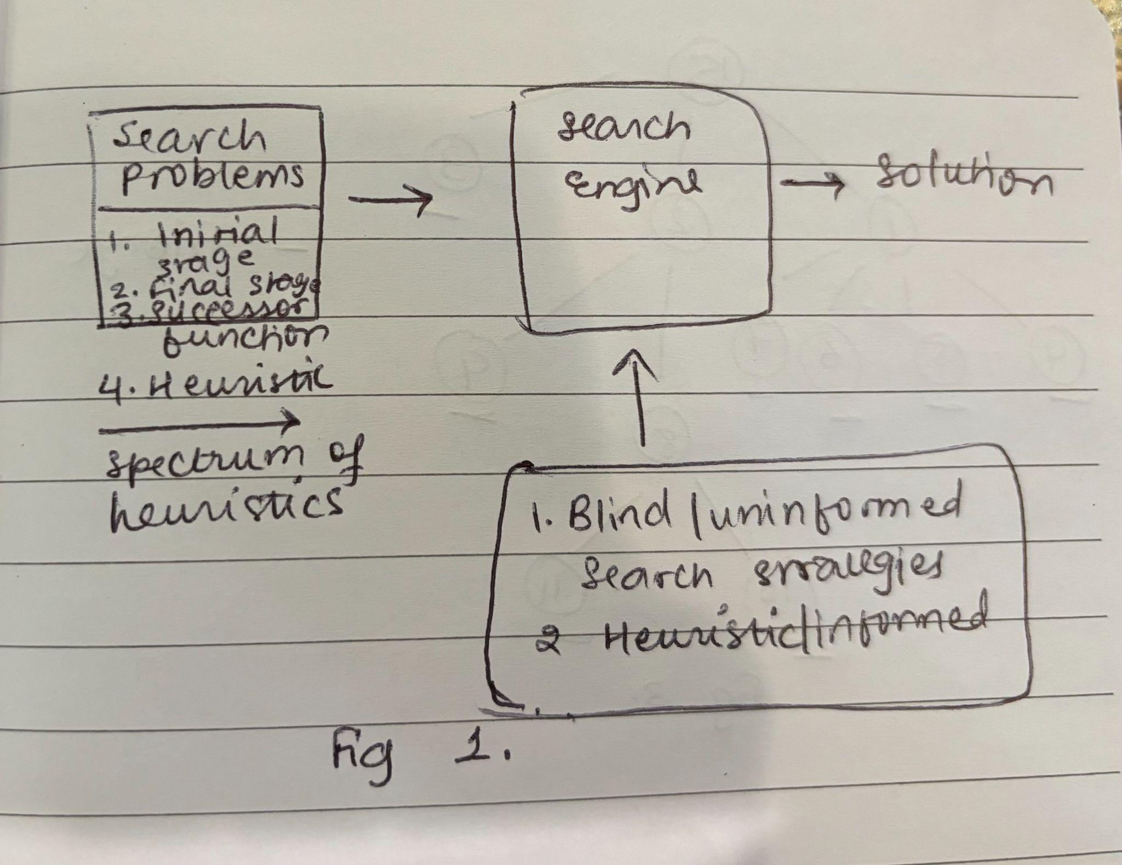

***Terminology***

* *Fringe/Frontier: unexplored nodes*
* *Generate: run the search function and the generate the children*
* *Expanding : [check if the node if FS, generate the children]*

***Observations about Trees***

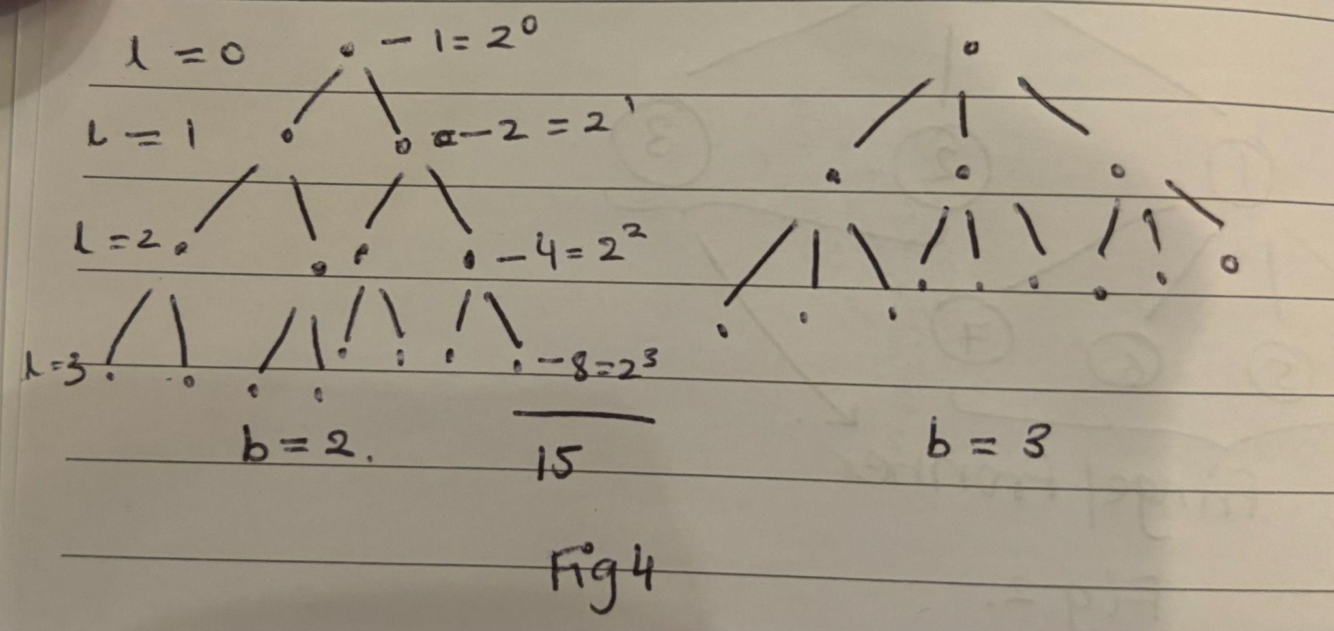

Number of nodes in a tree of depth d and branching factor b

${N(b,d) =b}^{0} + b^{1}+b^{2} + ....+b^{d}$

${bN(b,d) =b}^{1} + b^{2}+b^{3} + ....+b^{d+1}$

${bN(b,d) - N(b,d) =b}^{d+1}-1$

$N(b,d) = \frac{b}{b-1}b^{d}$ → O($b^{d}$)

***In such trees, the last level number of nodes dominates the tree and its dependent on the branching factor***

**The Search Process**

* Initial Stage
* Final Stage
* Search Function
* We start at the initial stage, check if it is the final stage and if not then we apply the search function to this to generate its children
  + 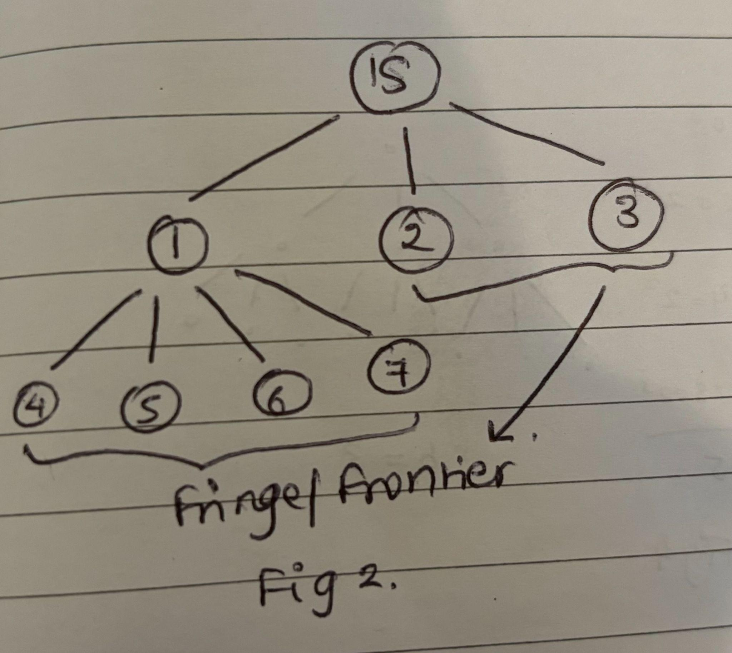
  + The unexplored nodes are called **fringe/frontier**
  + When we see a node, we first expand, generate and when we do this to a node, we are removing it from the fringe.
  + *Nodes on the fringe are waiting to be* ***expanded***
  + 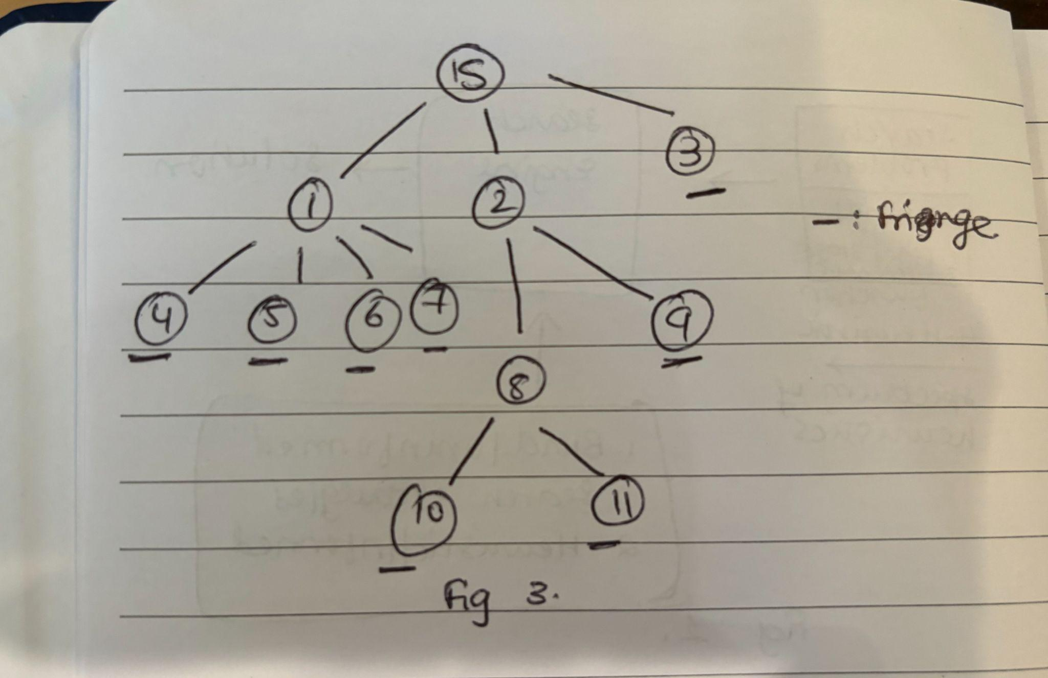
* A “**search strategy**” is a criteria for deciding which node on the fringe to expand next
  + Search strategy is used to find a path from the initial to the final stage
  + *Check for goal during expansion not generation*

**The four dimensions of a search strategy:**

* **Completeness**
  + Does it always find a solution if one exists?
  + Some popular search strategies are not complete, but they return that it could not find any path
* **Time Complexity**
  + Number of nodes expanded
  + Can never be better than space complexity
* **Space Complexity**
  + Maximum number of nodes in memory
* **Optimality**
  + Does it always find the least cost solution (optimal solution)

**The three aspects of a search strategy:**

* **b**: branching factor (number)
  + Number of children a particular node has
  + Games: branching factor represents the average number of moves or decisions available from any given state
  + In a tree or graph, the branching factor is the average number of children each parent node has.
* **d**: depth of the optimum solution
* **m**: maximum depth of the tree
  + Could be infinite

**Search Strategy 1: Breadth First Search (BFS)**

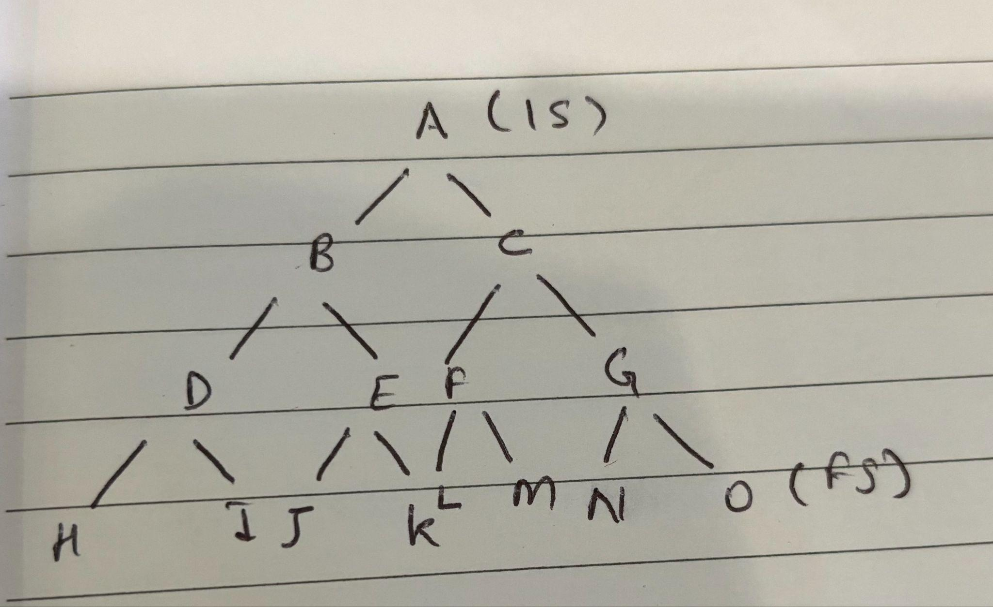

* Search Strategy (one-liner to determine which node should be expanded): Shallowest node first
* Memory tracking
  + We start with A, check if it is the goal and if not it expands the node
  + Now the picture looks like:   
     A  
     / \  
     B C
  + Now we can expand either as it is at the same level. Say we keep expanding along B.
  + 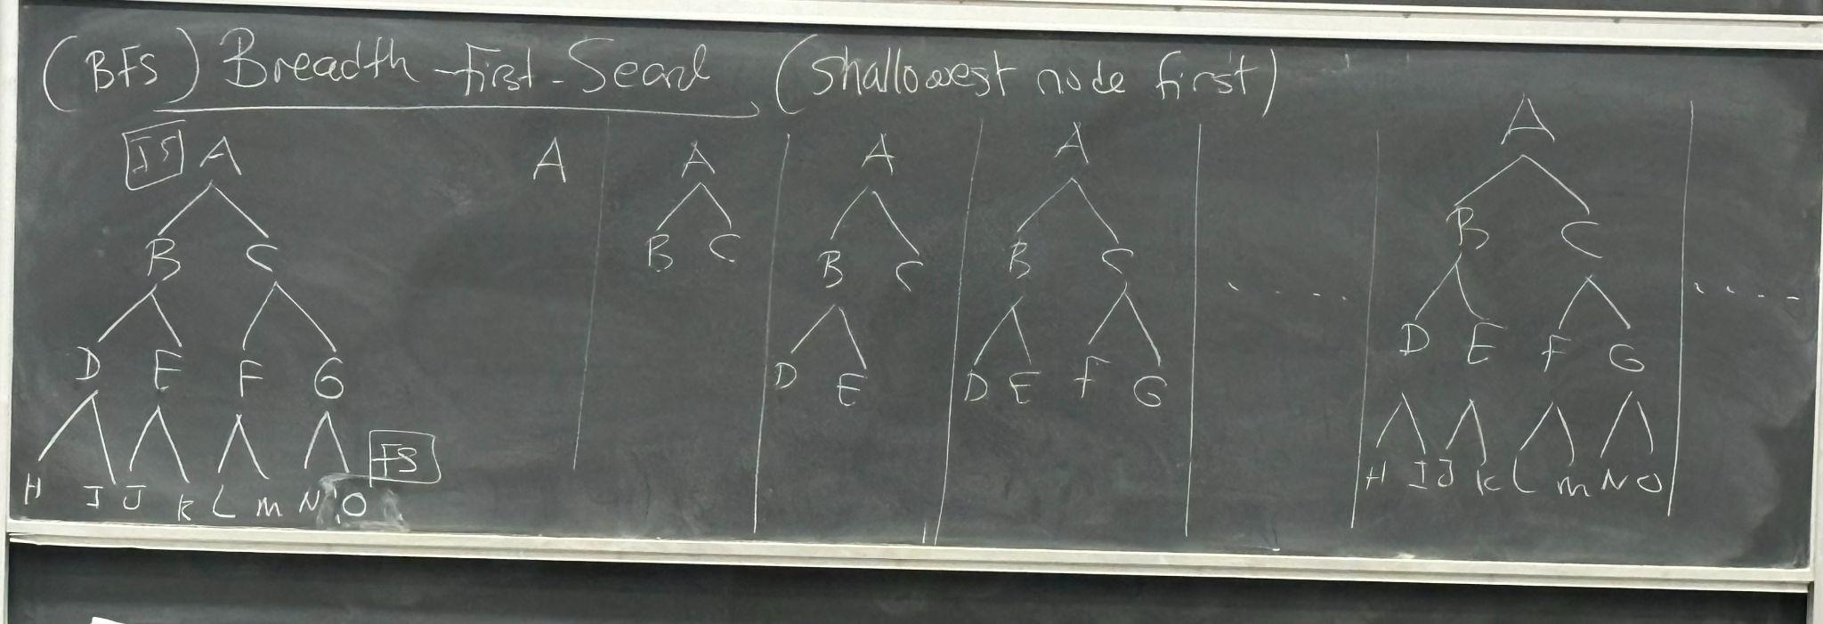
* We look at the original tree and number the nodes how they were expanded:
  + A: 1
  + B: 2
  + C: 3
  + D: 4
  + E: 5
  + F: 6
  + G: 7 …
* In this data structure we maintain the fringe as a **queue data structure**.
  + A → BC → CDE → DEFG …
* *BFS does not expand the node at level L, until it has expanded all nodes on the previous level*
* Complete: Yes
* Time Complexity: $b^{d}$
* Space Complexity: $b^{d}$ (pretty terrible 👹)
* Optimality: Yes

**Search Strategy 2: Depth-First Search (DFS)**



* Search Strategy (one-liner to determine which node should be expanded): deepest node first
* Memory tracking:
* 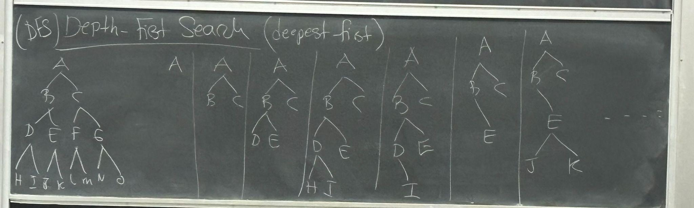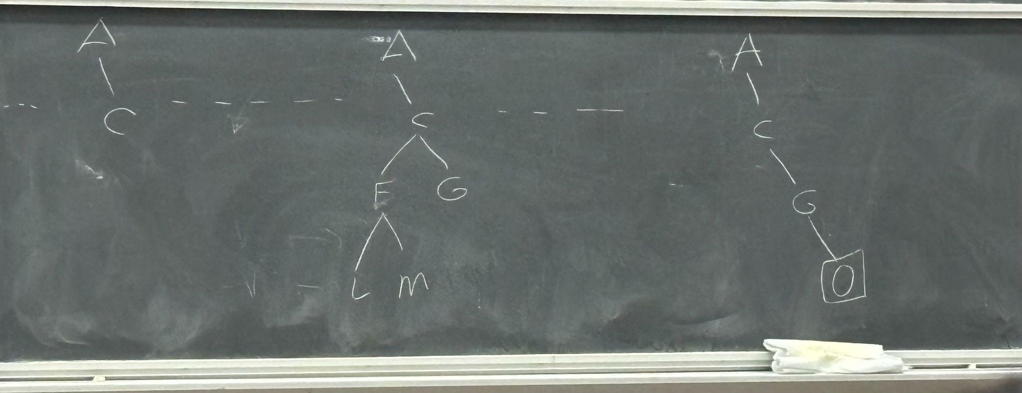
* We look at the original tree and number the nodes how they were expanded:
  + A: 1
  + B: 2
  + D: 3
  + H: 4
  + I: 5
  + E: 6
  + J: 7 …
* To manage the fringe, we use a stack
* Complete: No
  + DFS can get stuck exploring an infinite path without ever reaching a solution, even if one exists
* Time Complexity: $b^{m}$
* Space Complexity: bm (linear space complexity)
* Optimality: No (kind of stops as soon as it hits solution, with the earliest path)

**Contrasting BFS and DFS**

|  | **BFS** | **DFS** |
| --- | --- | --- |
| Completeness | Yes | No |
| Optimal | Yes | No |
| Time Complexity | $b^{d}$ | $b^{m}$ |
| Space Complexity | $b^{d}$ | bm(linear) |
| One-liner | Shallowest node first | Deepest node first |
| DS Used | queue | stack |
| **In Essence** | **Expands the shallowest node first, uses a queue data structure and has to keep track of what nodes previously visited** | **Expands the deepest node first, and thus terminates even at the non optimal solution, if it hits the goal state** |

**Search Strategy 3: Depth-Limited Search (L)**

* Cut off at the some depth L
  + Helps prevent cases of infinite search at depth
* Complete: Yes if $L≥d$
  + If the first solution is at 18, and we cut off at 15 then this doesn’t return a solution
$O(b^{L})$

* Optimal: Yes if $L=d$
  + O(bL)

**Search Strategy 4: Iterative Deepening (ID)**

* *Promise: it will be complete, optimal, and linear space complexity without any additional information beyond Initial Stage, Final Stage*
* 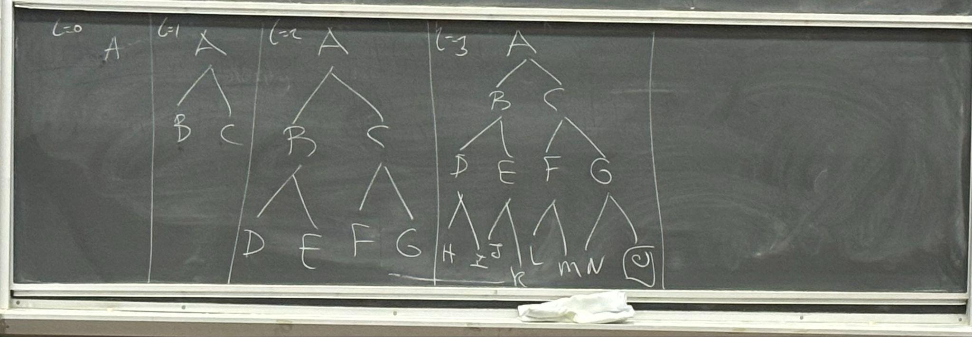
* Numbering:
  + L = 0
    - A: 1
  + L = 1
    - A: 2
    - B: 3
    - C: 4
  + L = 2
    - A: 5
    - B: 6
    - D: 7
    - E: 8
    - C: 9
    - F: 10
    - G: 11

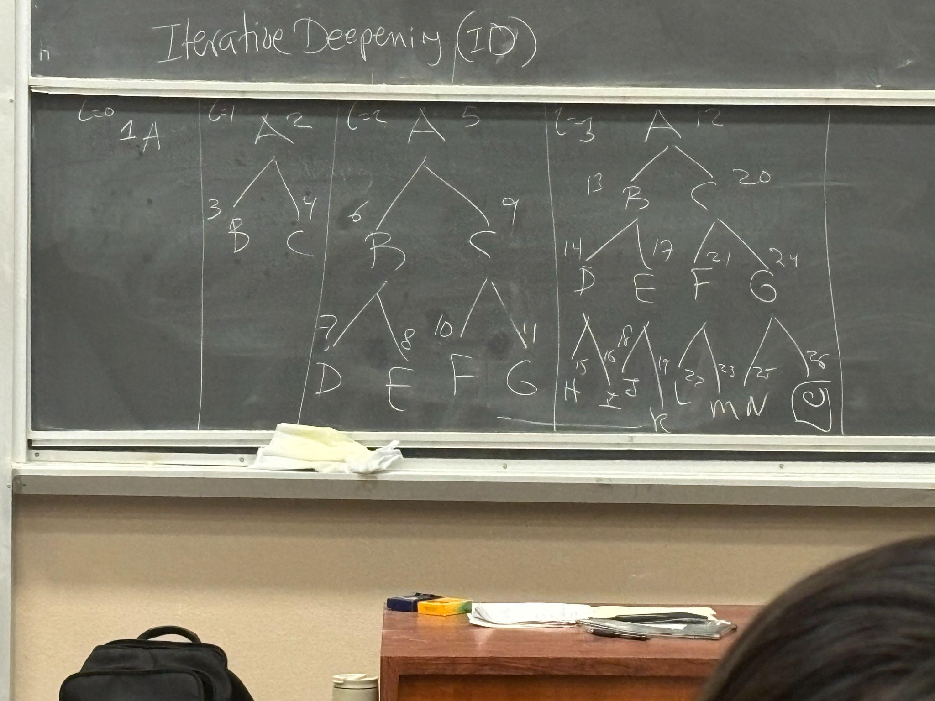

* + A node can have more than one numbering as it is expanded multiple times.

* Complete: Yes
* Time Complexity:
  + - If b = 2 → factor = 2
    - If b = 3 → factor = 1.5
    - If b = 10 → factor = 1.11
  + As branching factor grows the factor vanishes
* Space Complexity: bd
* Optimal: Yes
* **Benefits vs Drawbacks Analysis**

| Benefits | Drawback |
| --- | --- |
| it covers the search space level by level, much like Breadth-First Search (BFS) | One major drawback of IDDFS is the overhead caused by repeatedly visiting the same nodes. |
| When the path costs are uniform, IDDFS is optimal. It finds the shallowest (least-cost) solution first |  |

# 4/10/2024

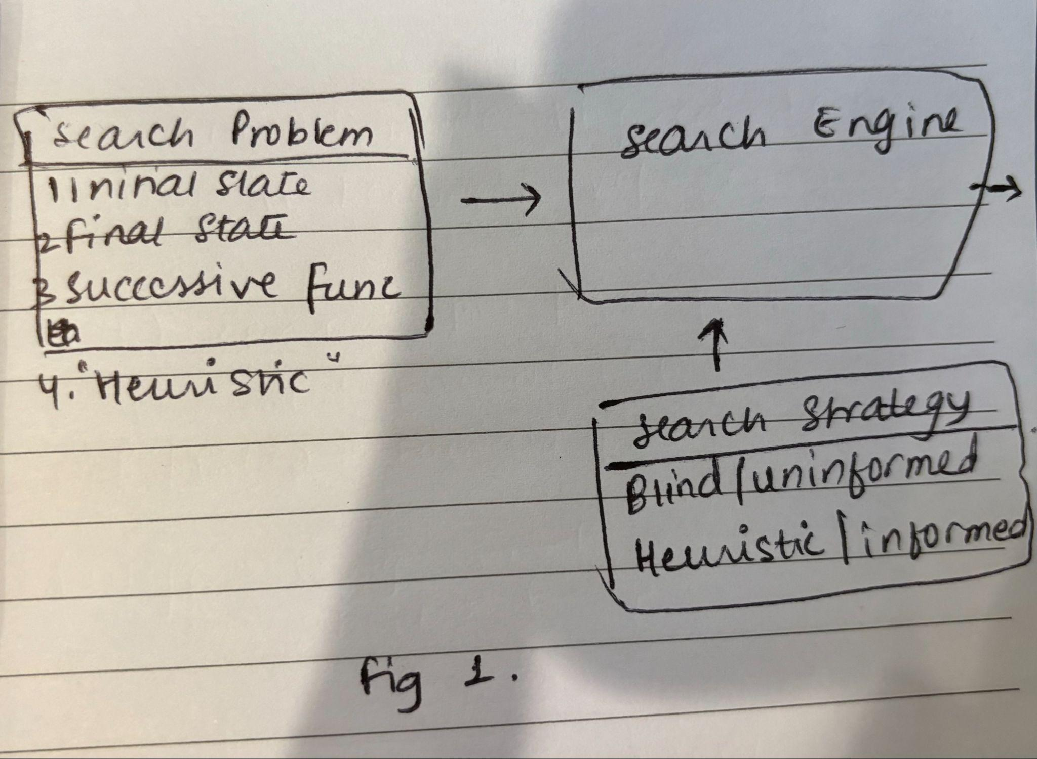

Blind/uninformed search strategies only require initial state, final state, and Function.

**Uniform-Cost Search**

* Generalizes BFS to allow action cost > 0. In BFS action cost == 1
* **State space**
  + Enumerates states
  + Enumerates actions and their costs
* 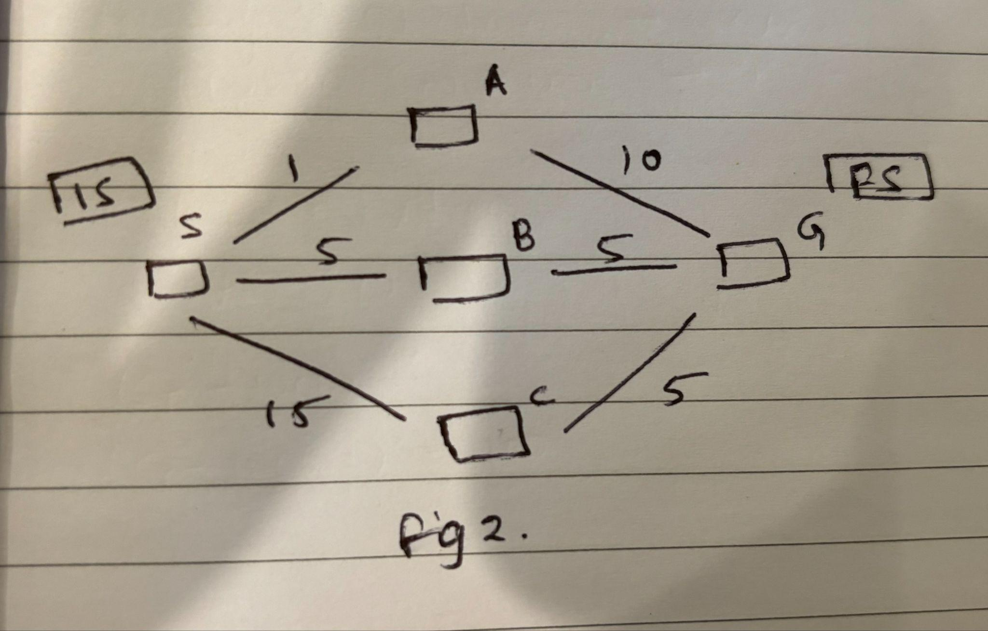
* Now for the above figure, we will:
  + Expand node
    - Check if node is FS
    - If not, generate children
  + Begin with S (IS), and only one node in fringe. As S is not FS, we expand,
  + For the general expansion, we want to expand the minimum number of the fringe.

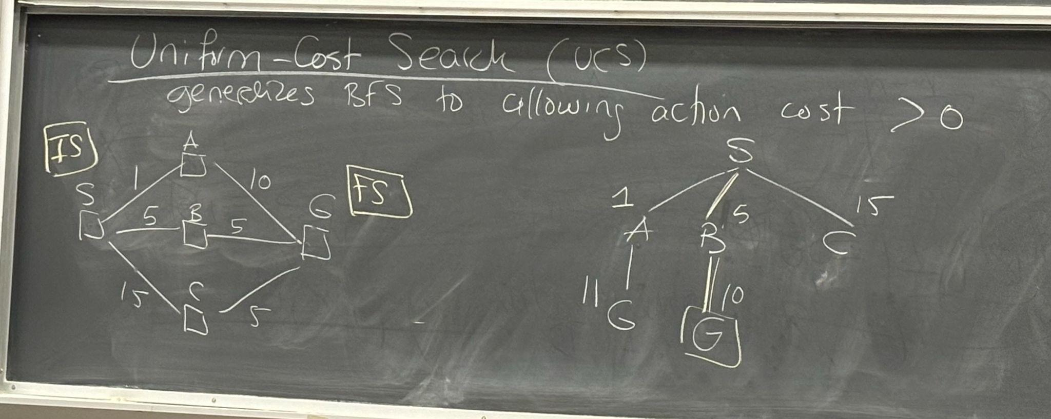

* + We can have more than one G on the fringe as they have different paths.
  + *We can only find the solution when we pick a node to expand. We stop the minute when we find the goal.*
* ***If this algorithm is expanding a certain node from the fringe, then it has already expanded everything that costs lower.***
* Complete: Yes
* Optimal: Yes
* Time Complexity: $b^{c*ε}$
  + c*: cost of optimal solution (say 0.5)
  + ε: smallest possible cost (say 5)
* Space Complexity: $b^{c*ε}$
* Example: initial state A, final state B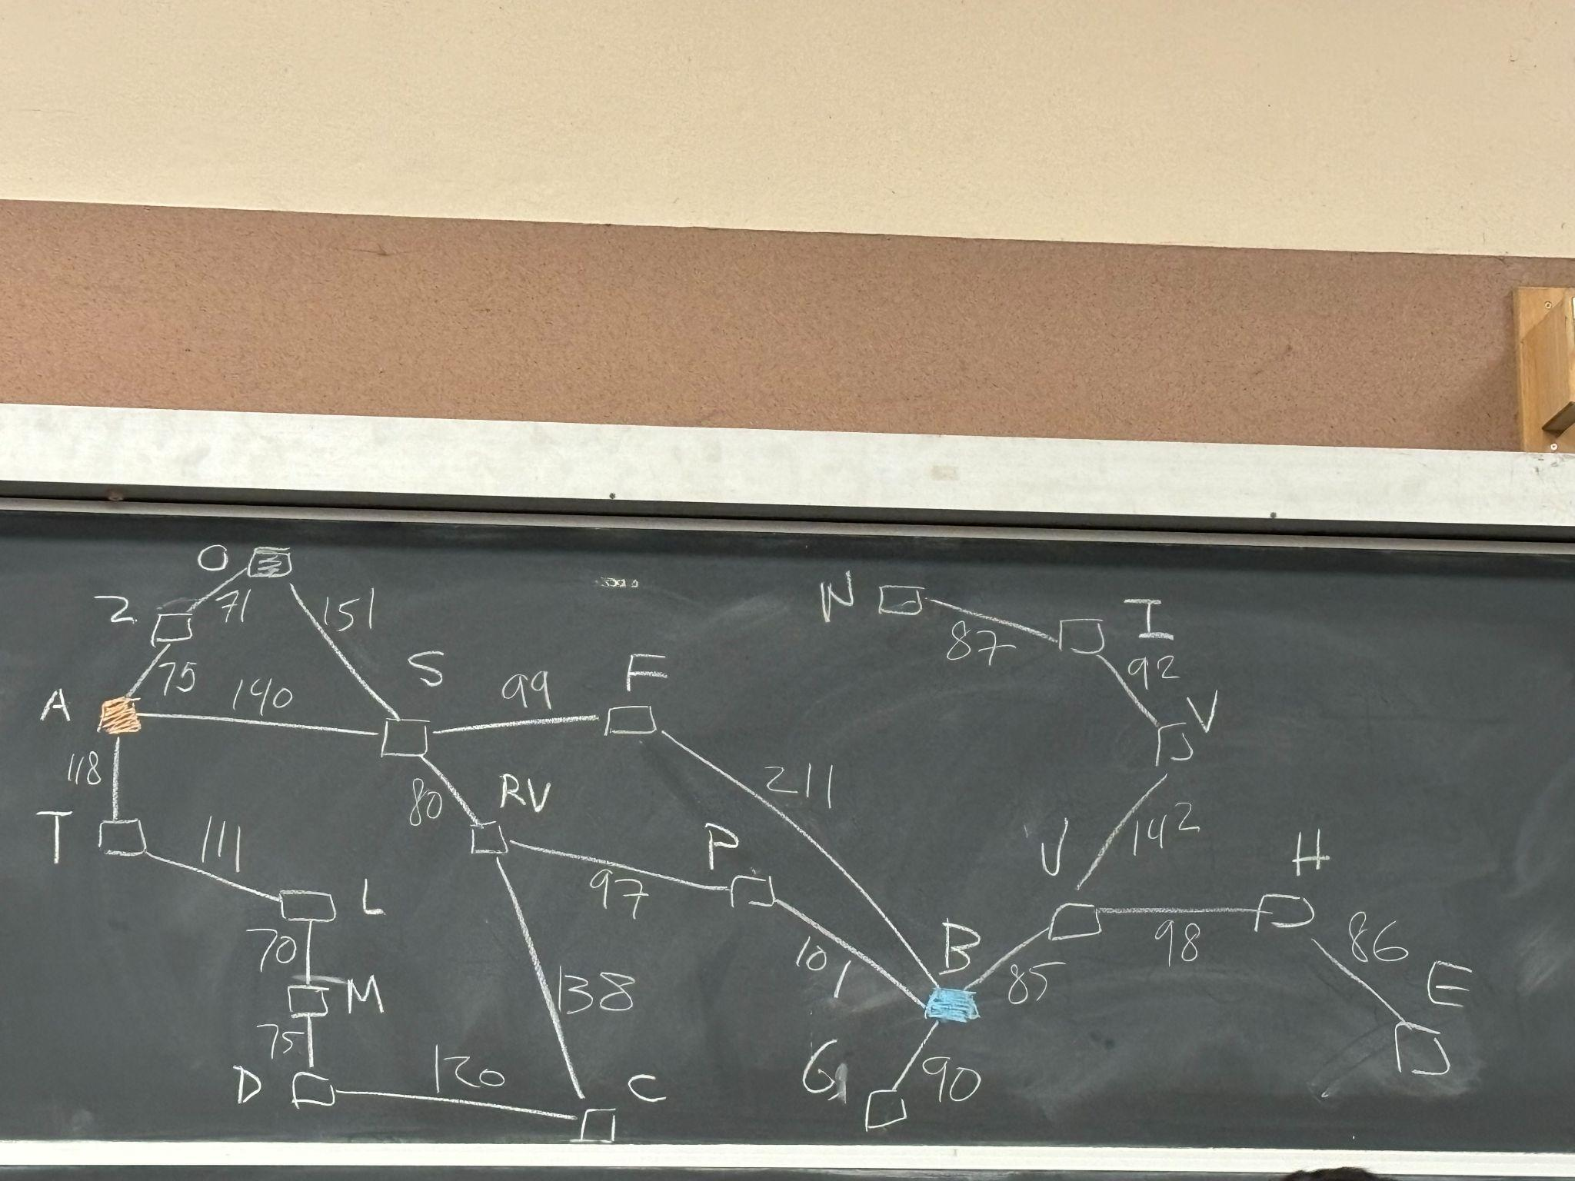
  + Strategy 1 (Blind-Search):
    - 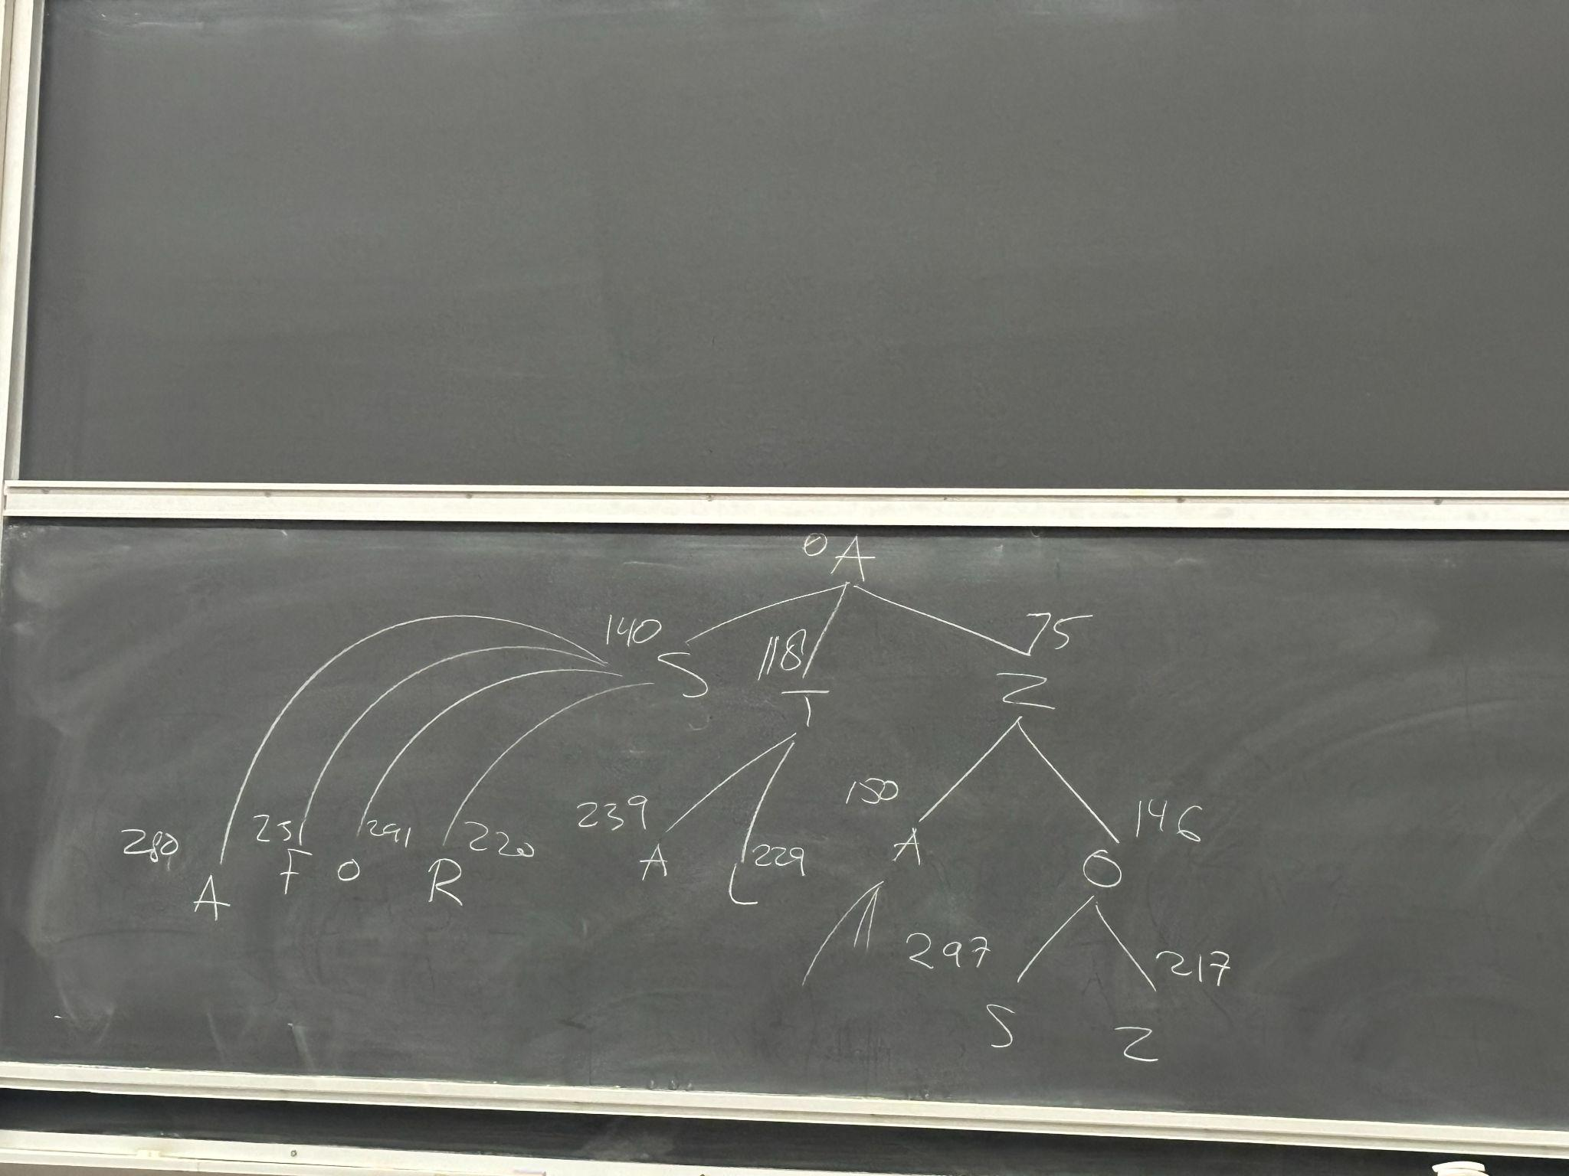
    - *Every past candidate and the minimum of how much we paid so far*
    - Final solution: A – S – RV – P – B => cost: 418
    - Slow, but optimal
    - Blind-search
    - **g(n)** is the term we will use for the cost i.e the total cost from IS to FS
      * **Cost so far to reach n**
  + Strategy 2 (Heuristic): using minimum straight line distance
    - 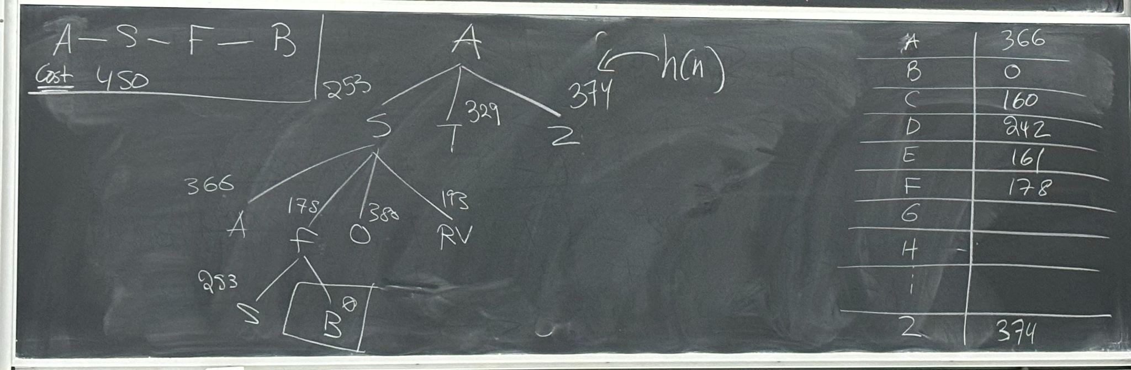
    - *Ignoring how much we paid so far, and focussing on how close we are to the goal*
    - Final Solution: A – S – F – B => cost: 450
    - **h(n)** what is the cost of going from n to the goal, the heuristic
      * **Estimated cost from n to goal**
      * The computation is expected to be really fast
    - Able to finish fast but get non optimal solution
* ***Our solutions have redundancy and repetition, we are letting it be, as if we do pruning and removing redundancies then that messes up the complexity***

**A* Algorithm**

* ***How do we get the best out of two?***
  + ***f(n)*** *= g(n) + h(n)* 
    - *Evaluation function*
    - *Estimated total cost for a solution/path that goes through n*
  + 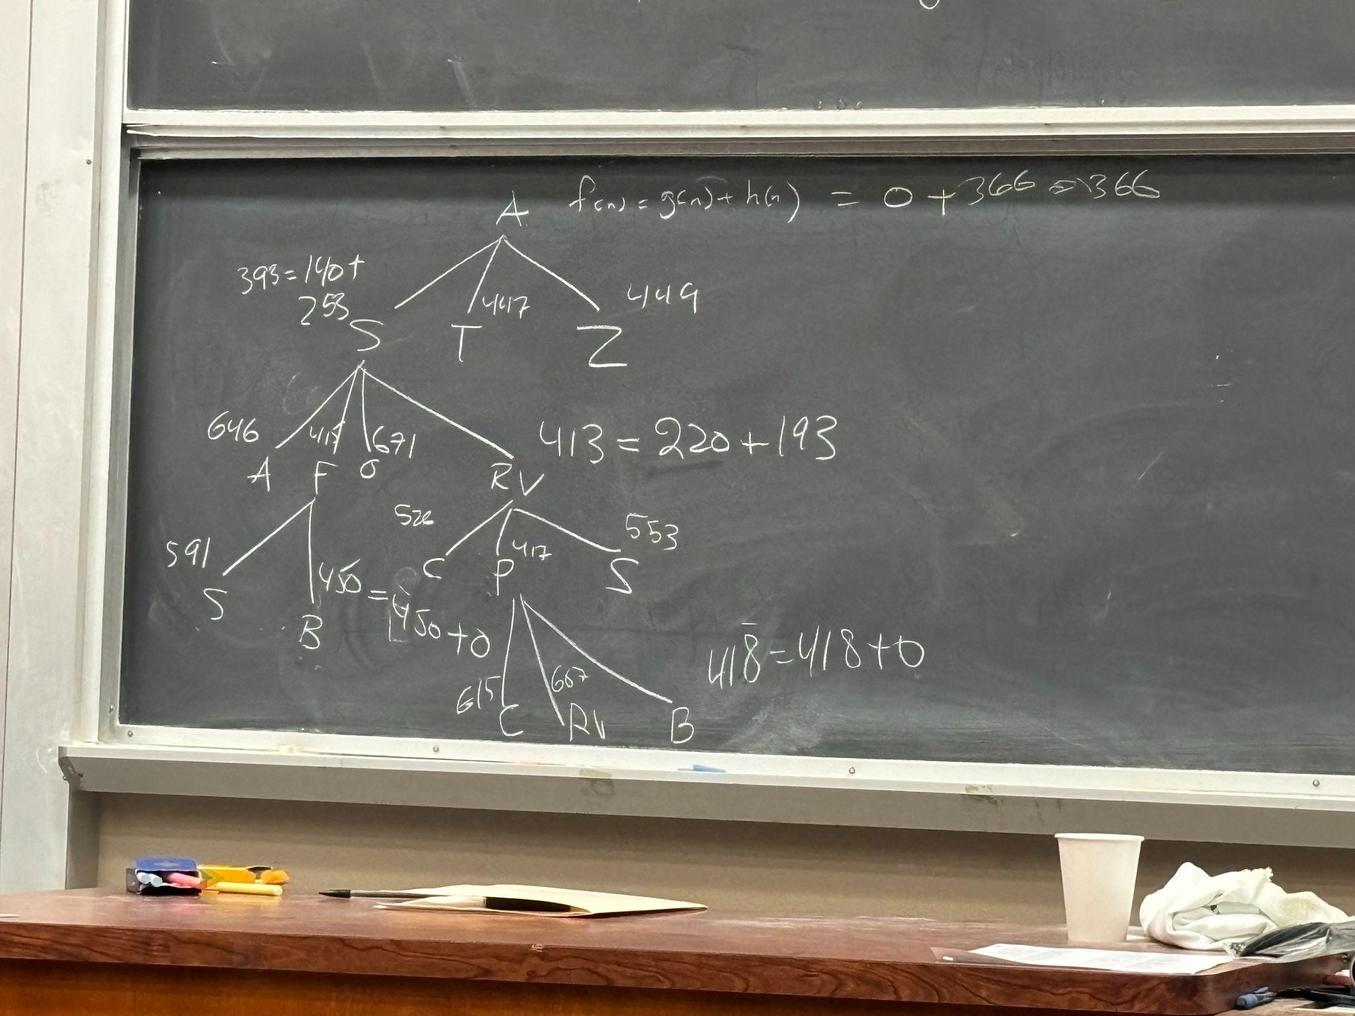
  + Condition to guarantee optimality:
    - Heuristic h(n) must be **admissible**
      * $h(n) ≤h*(n)$ → h*(n) is the optimal cost for going from n to FS
 $h(n)≥0$

   - When h(n) == 0 for A* we get Uniform Cost Search
    - We would like the h(n) to be as high as possible but still being admissible

**Eight-Square Problem**

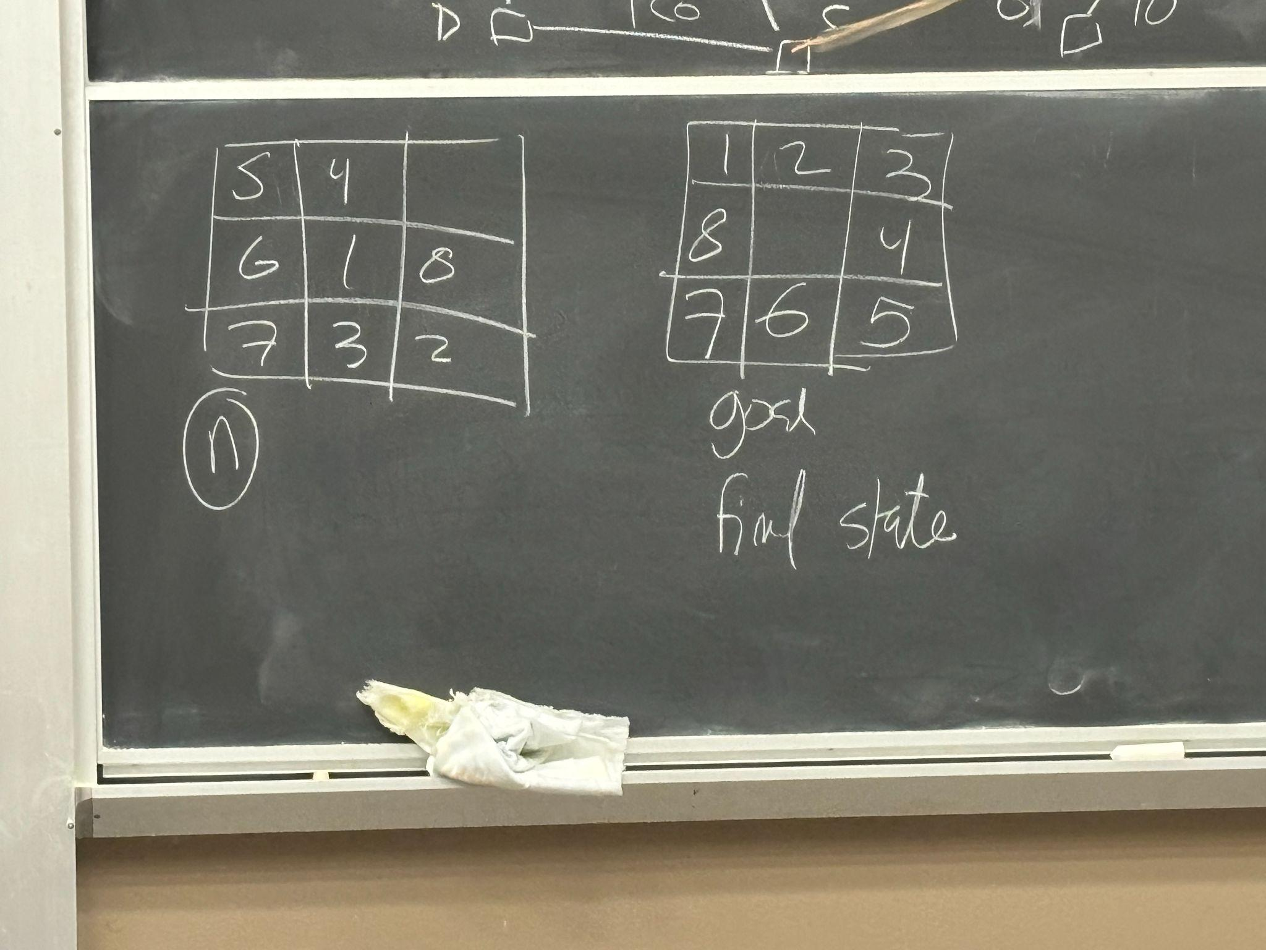

* Heuristic: look at the board and count how many tiles are not in their position, and that’s the minimum number of tiles that we need to move
* We can now run A* but we can also **do better**!
  + We can calculate the heuristic using the manhattan distance between initial and final positions
* 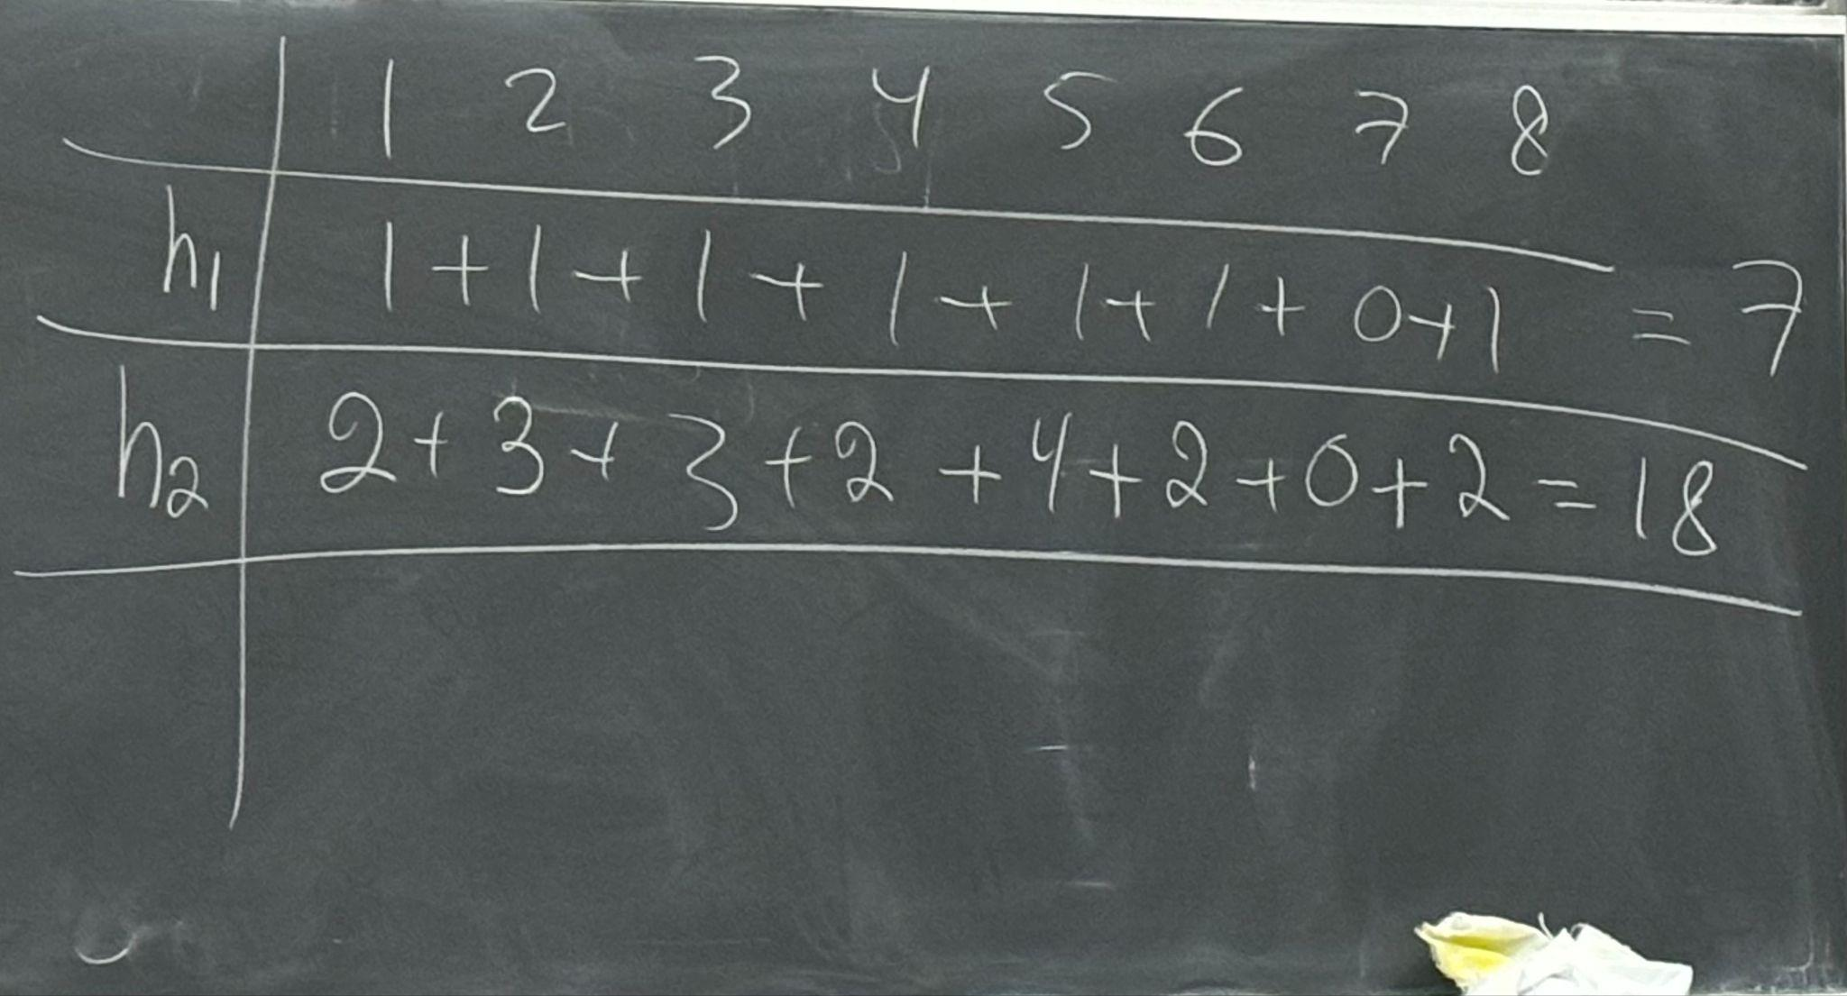
* Notice that $h_{2}(n)≥h_{1}(n)$ → $h_{2} dominates h_{1}$
* Question:
  + Take either?
* 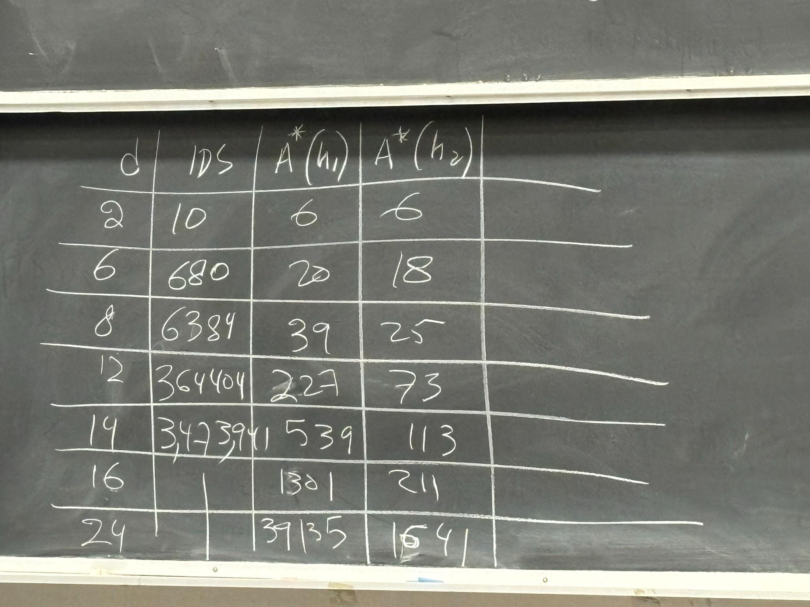
  + d is the minimum number of moves in an ideal scenario

# 4/15/2024

**Constraint Satisfaction Problems**

* Definition CSP
  + A set of variable and their possible values
  + A set of constraints
* Different types of constraints:
  + Unary constraints (Ex1: $SA≠Red)$
  + Binary constraints (Ex1: $SA≠WT)$
  + Higher order constraints
  + Hard constraints → must be satisfied
  + Soft constraints → not all can be satisfied so we weigh the constraints
    - IDEA: find a solution that satisfies weights of constraints
* Examples
  + Example 1: Map coloring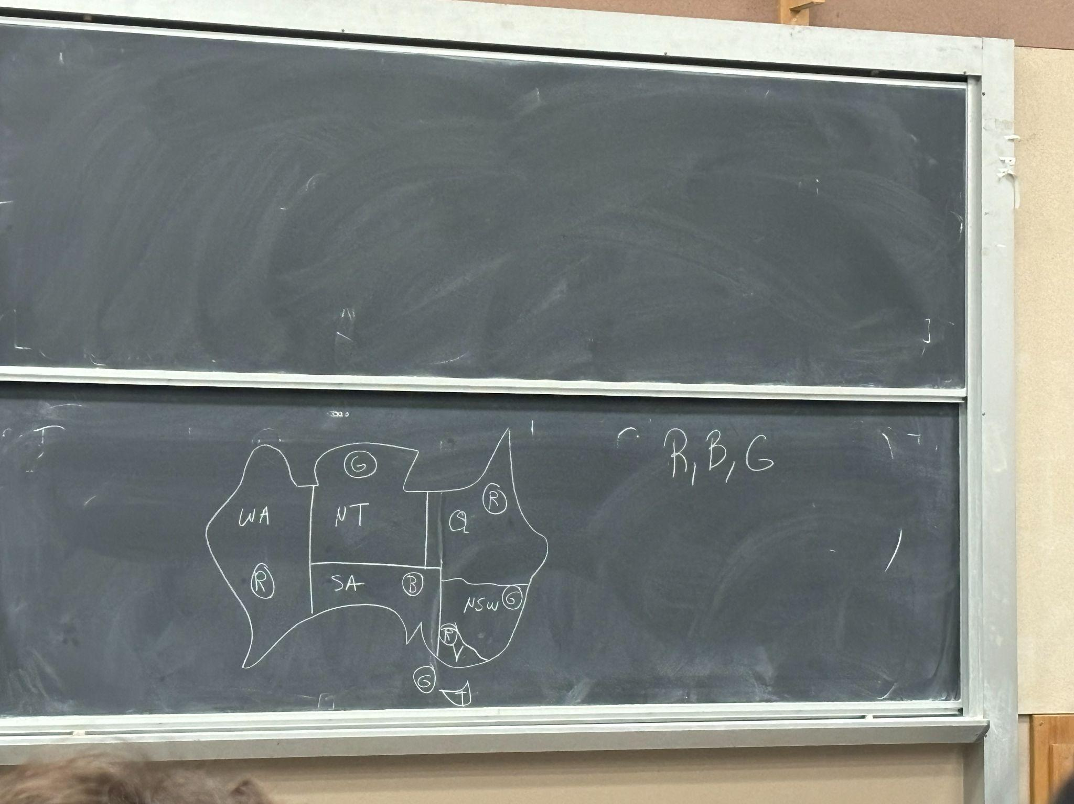   
     We have to color the states with RBG such that no two states have the same color. Type of problem: graph coloring
    - In the above, the states are the variable (WA, NT, Q, NSW, V, SA, T) → their possible values R, B, G (domain)
    - A set of constraints: $WA≠NT, WA≠SA ...$
    - **Constraint Graph**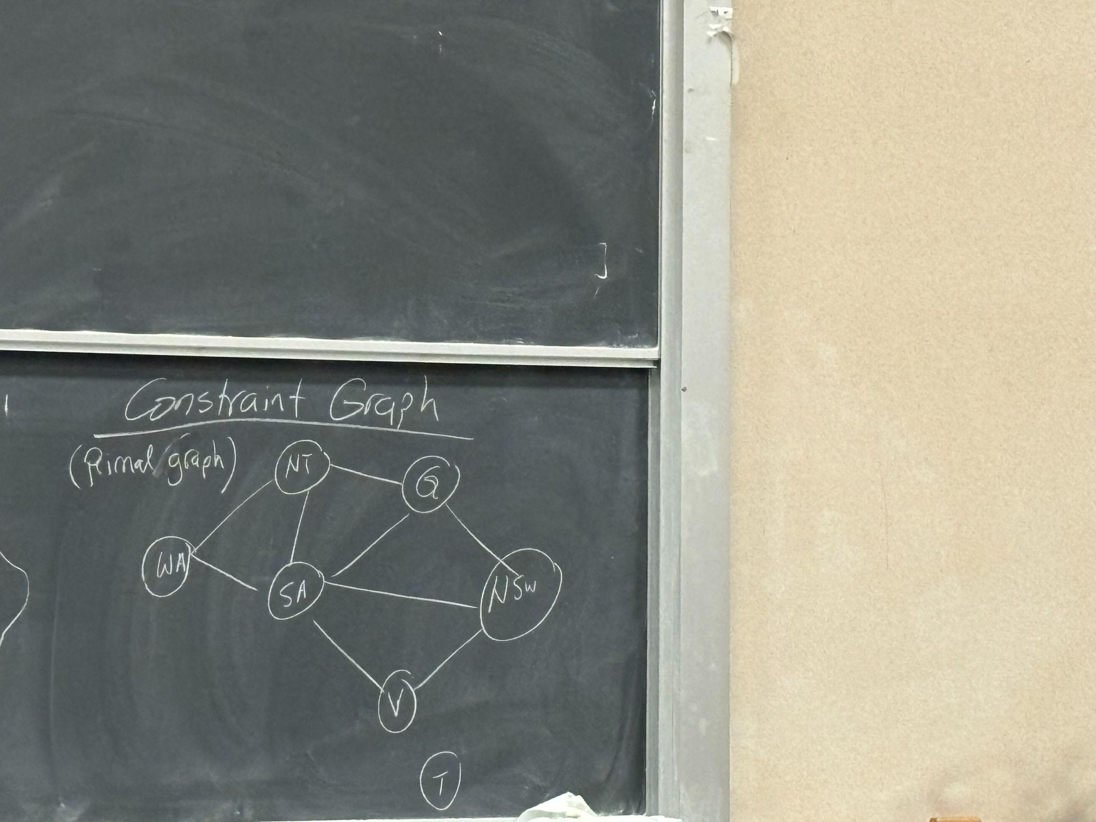
      1. If primal graph is a tree then solvable in linear time
      2. **Tree width** is important

Solution:   
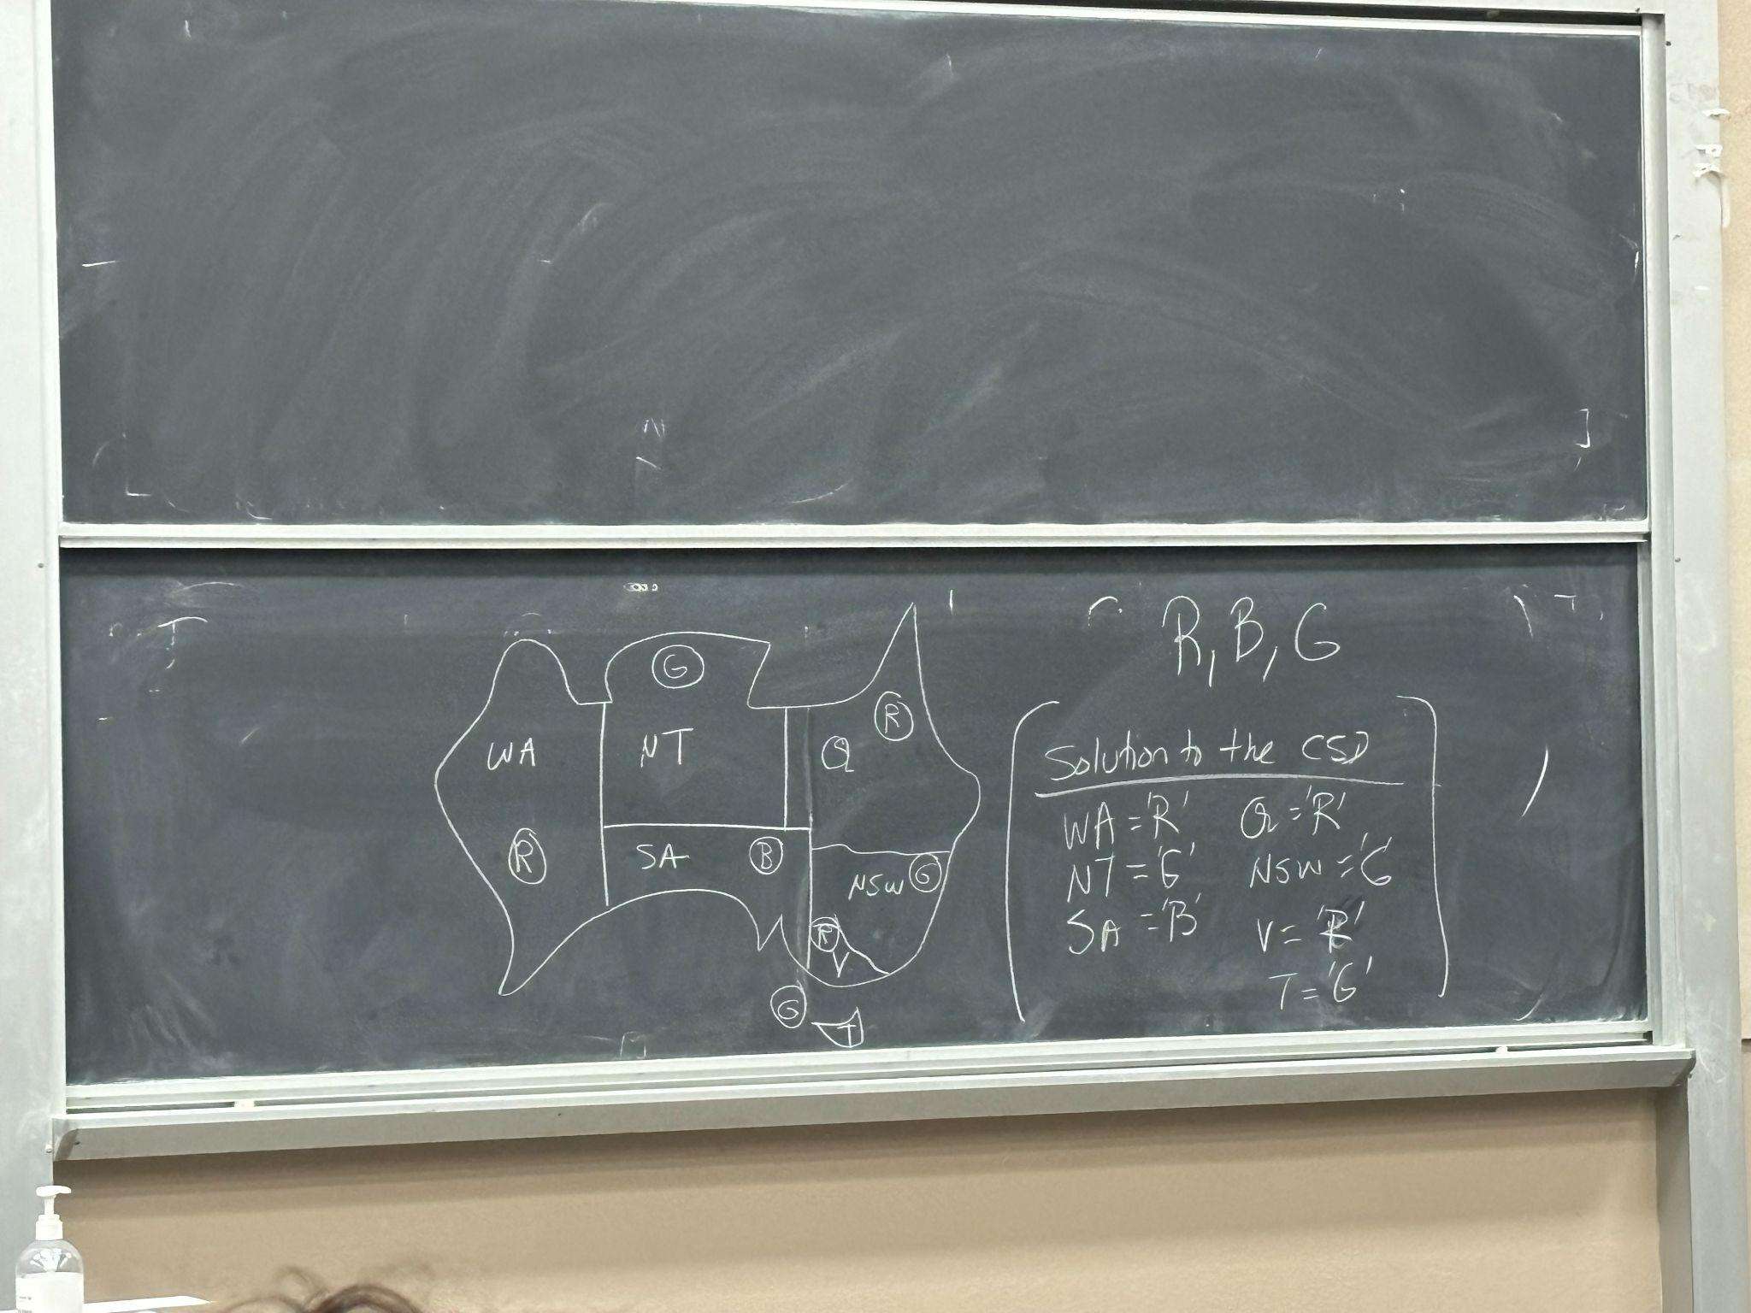

* Standard formation as search
* Standard search strategy
* Improvements (5)

**Satisfiability (SAT)**

We have

* variables: x1, x2 …xn
* Values: T/F, 1/0
* Constraints:
  + x1 V x2 V x4 (higher order)
  + x2 V x5 (binary)
  + !x7 (unary)

SAT (can you find me a solution) is np-complete (nondeterministic polynomial), and the very first np-complete problem discovered!   
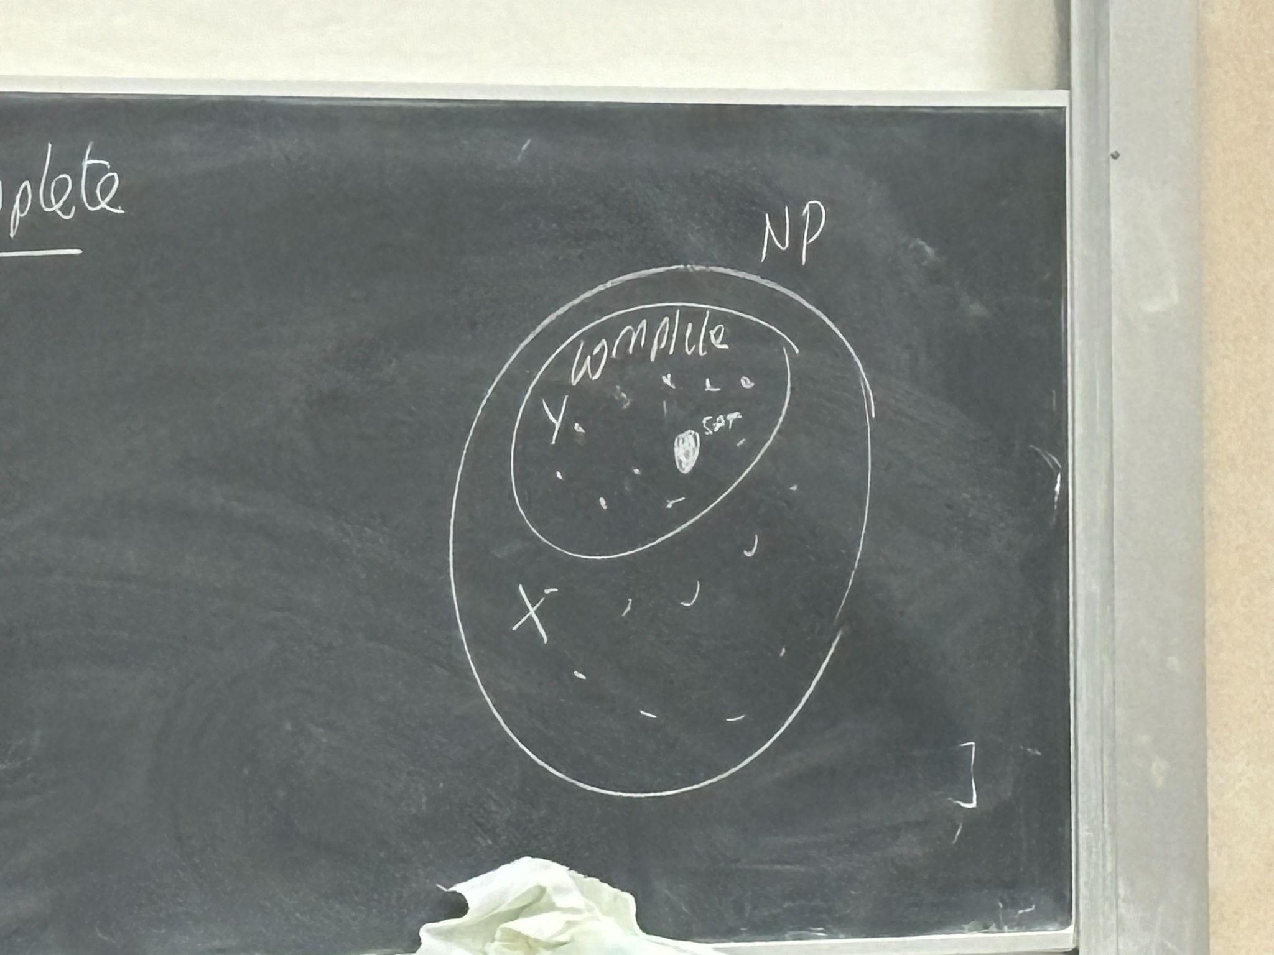

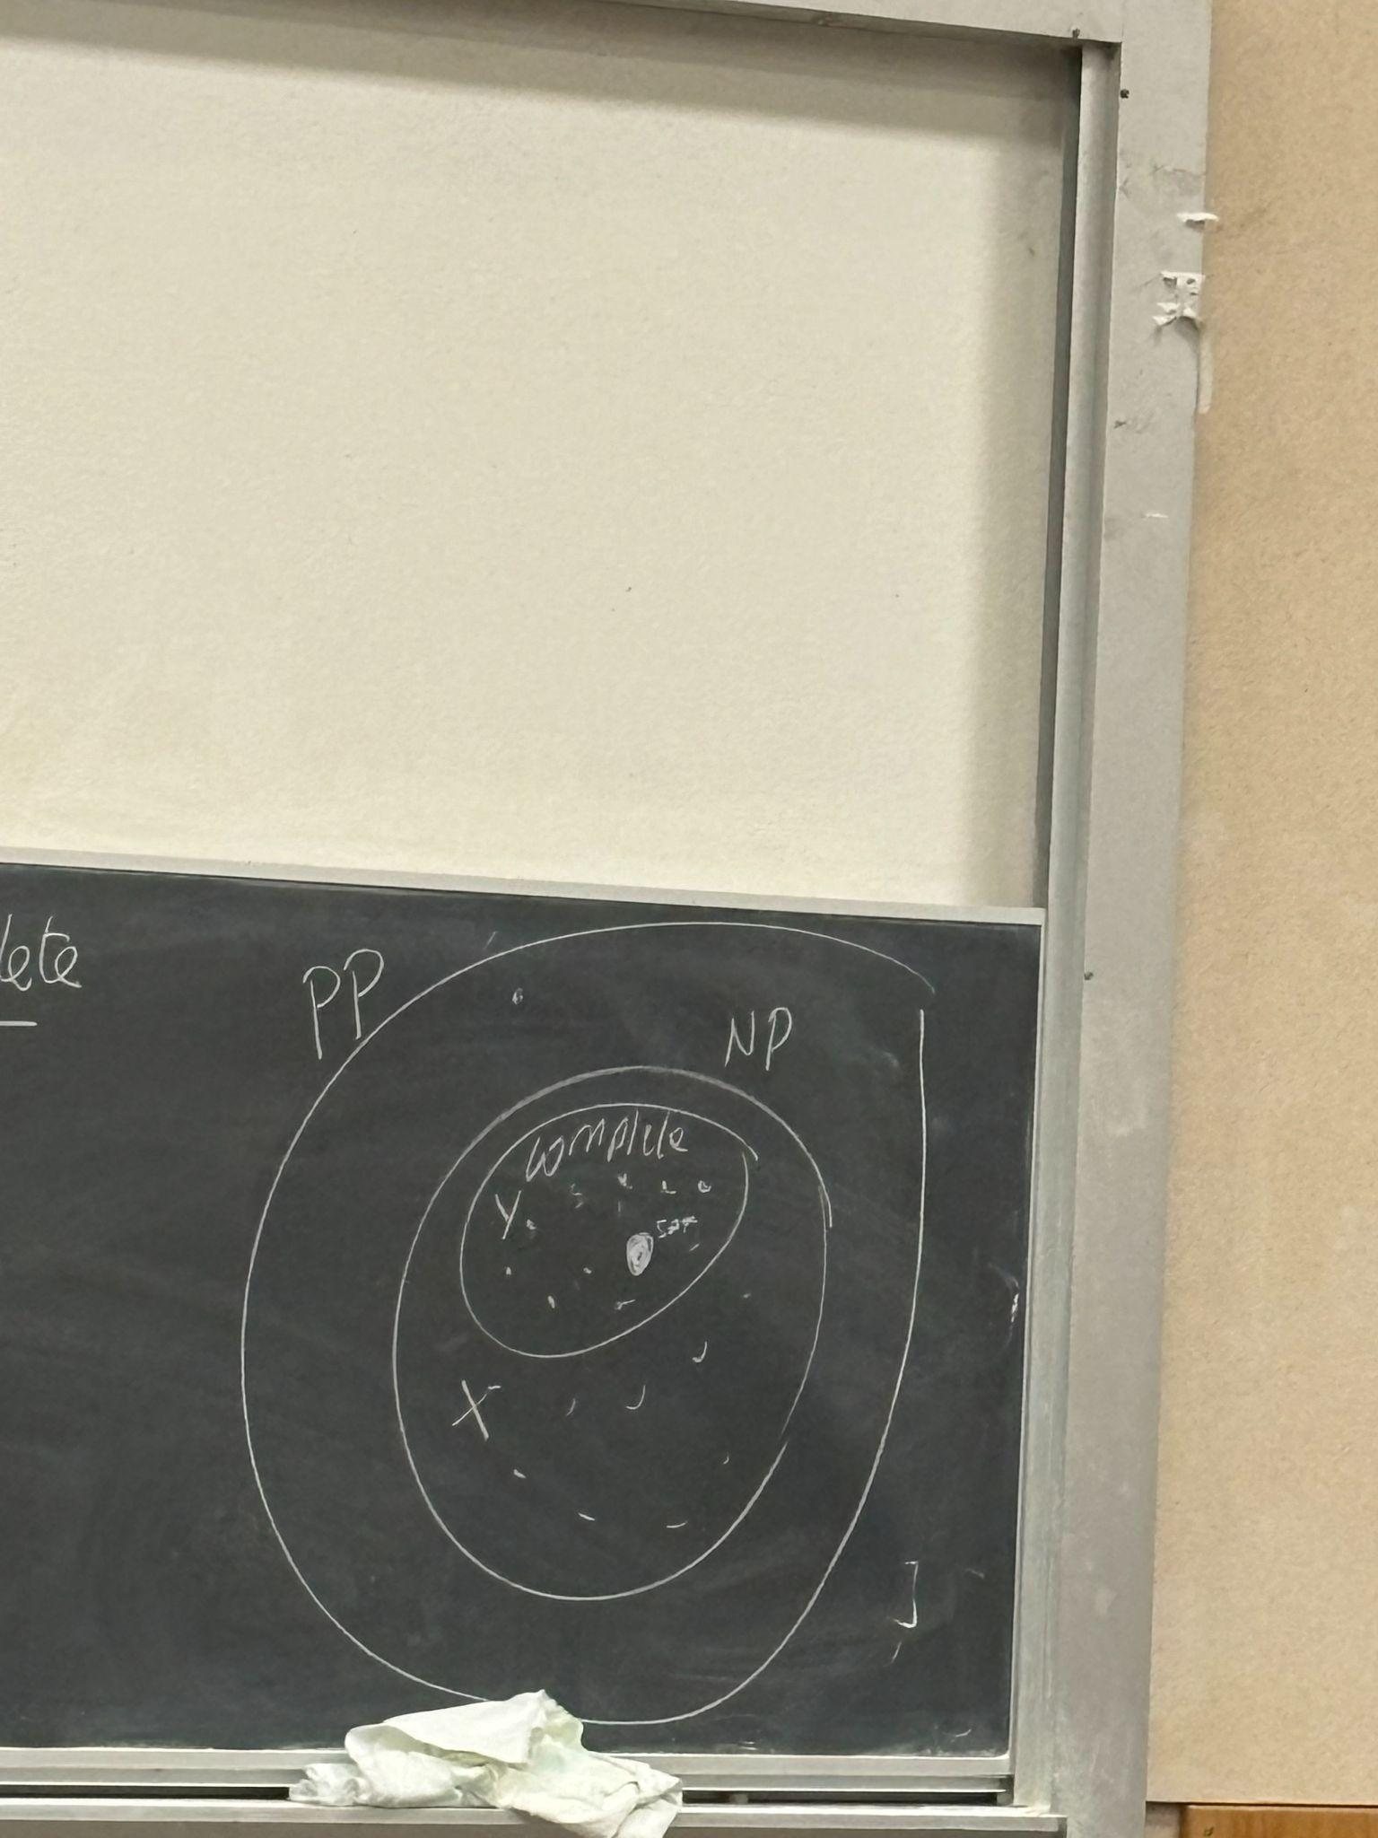

Counting the number of assignments is PP

**CSP as search**

* A **state** in this case is a partial variable assignment. We are going to imagine that:
  + Variable: x,y,z
  + Value: 0/1
  + Constraints: …
* Then states are:
  + {x=1}
  + {x=0, y=1}
  + {x=0, y=1, z=0} (complete state)
  + {} (empty)

The parameters are:

* Initial State : {}
* Final State: complete state that satisfies the constraints
  + FS test
* Successor Function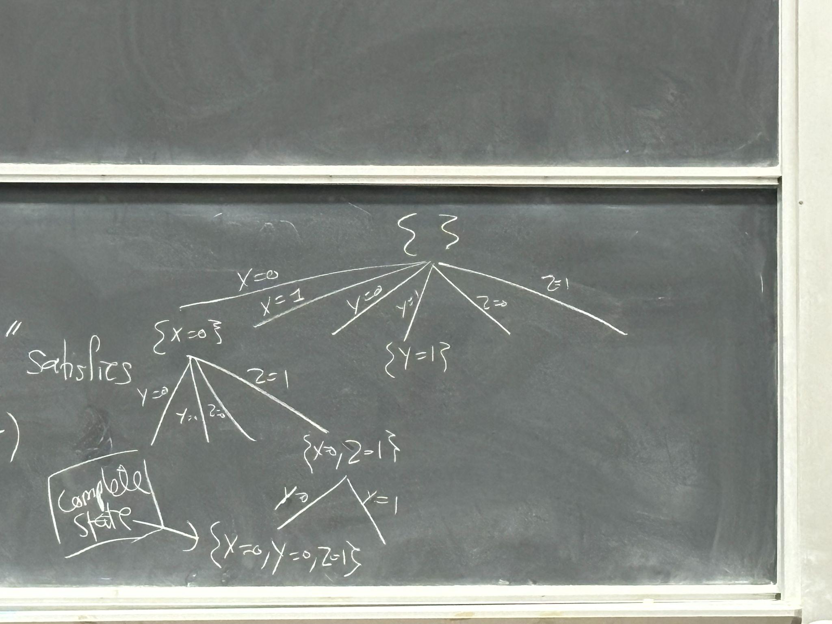

This is not a standard formulation! What’s the problem?

***There is a lot of redundancy***

* + - For n variables and d values, the number of nodes in this case: n! $d^{n}$
    - Whereas the distinct complete states are: $d^{n}$ = 8
  + **Augmentation:** We will first split on x, then y, then z.
    - 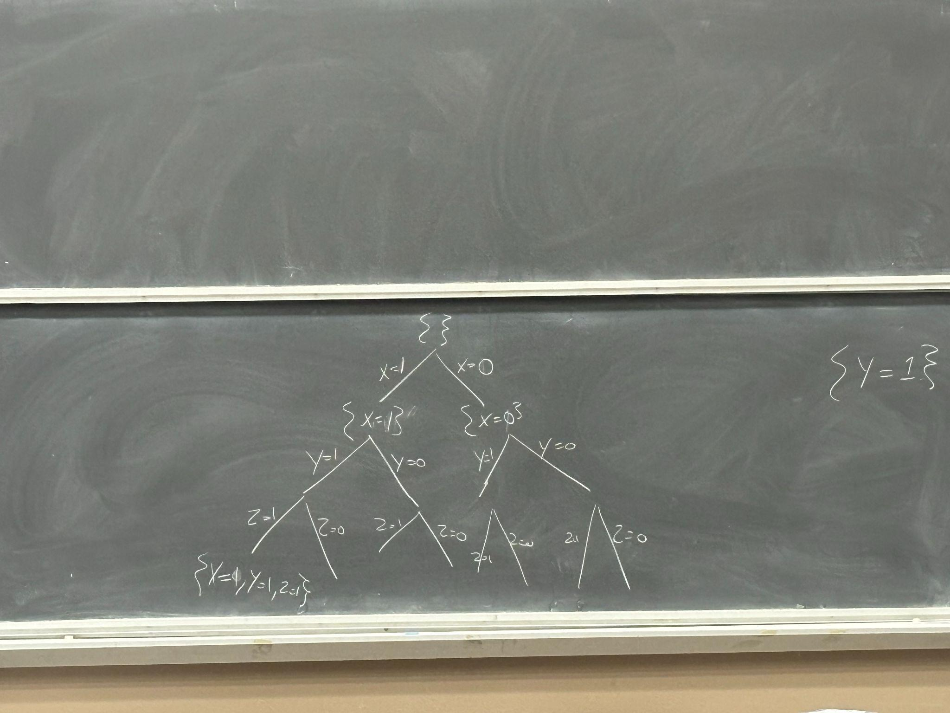
    - We can also use x → y → z on one side and x → z → y on the other (more on this later!)
    - But in this case the leaf nodes are the complete states. How do we find?
      * Not BFS: right now we don't have a notion of optimality,
      * Not Iterative Deepening: useful when did not know depth of solution
      * ***Use DFS or actually Backtrack search***
        + Backtrack search is a very fine augmentation of DFS
        + Branch and bound: optimization version, v important search technique
* heuristics
  + Variable ordering
  + Value ordering
  + Suppose:
    - Variables: x,y,z
    - Values 0/1
    - Constraints: x=y, y=z
    - Possible solutions: {x=y=z=0}, {x=y=z=1}
    - 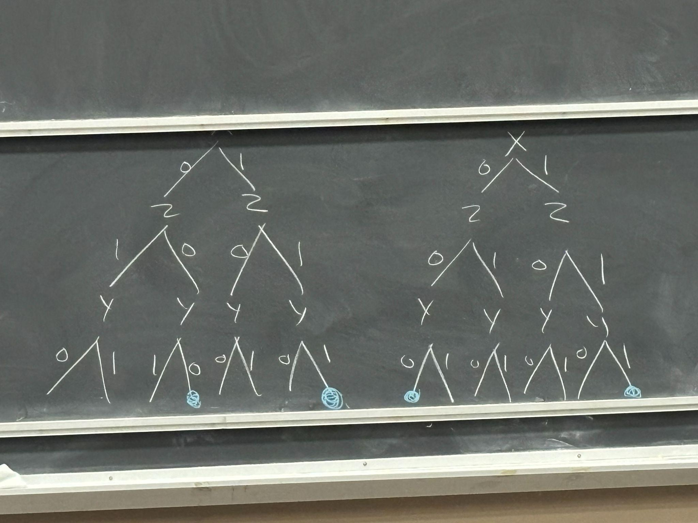  
      Value ordering here because it was much better and reaches a solution early by dfs.

**Backtrack search**

* Check whether the constraint is met. For example: if x = 0 and y = 1, is a constraint then i would not go out the branch where x = 1…
* If you are doing the map coloring, wif we start with nothing assigned, and draw the following tree:   
  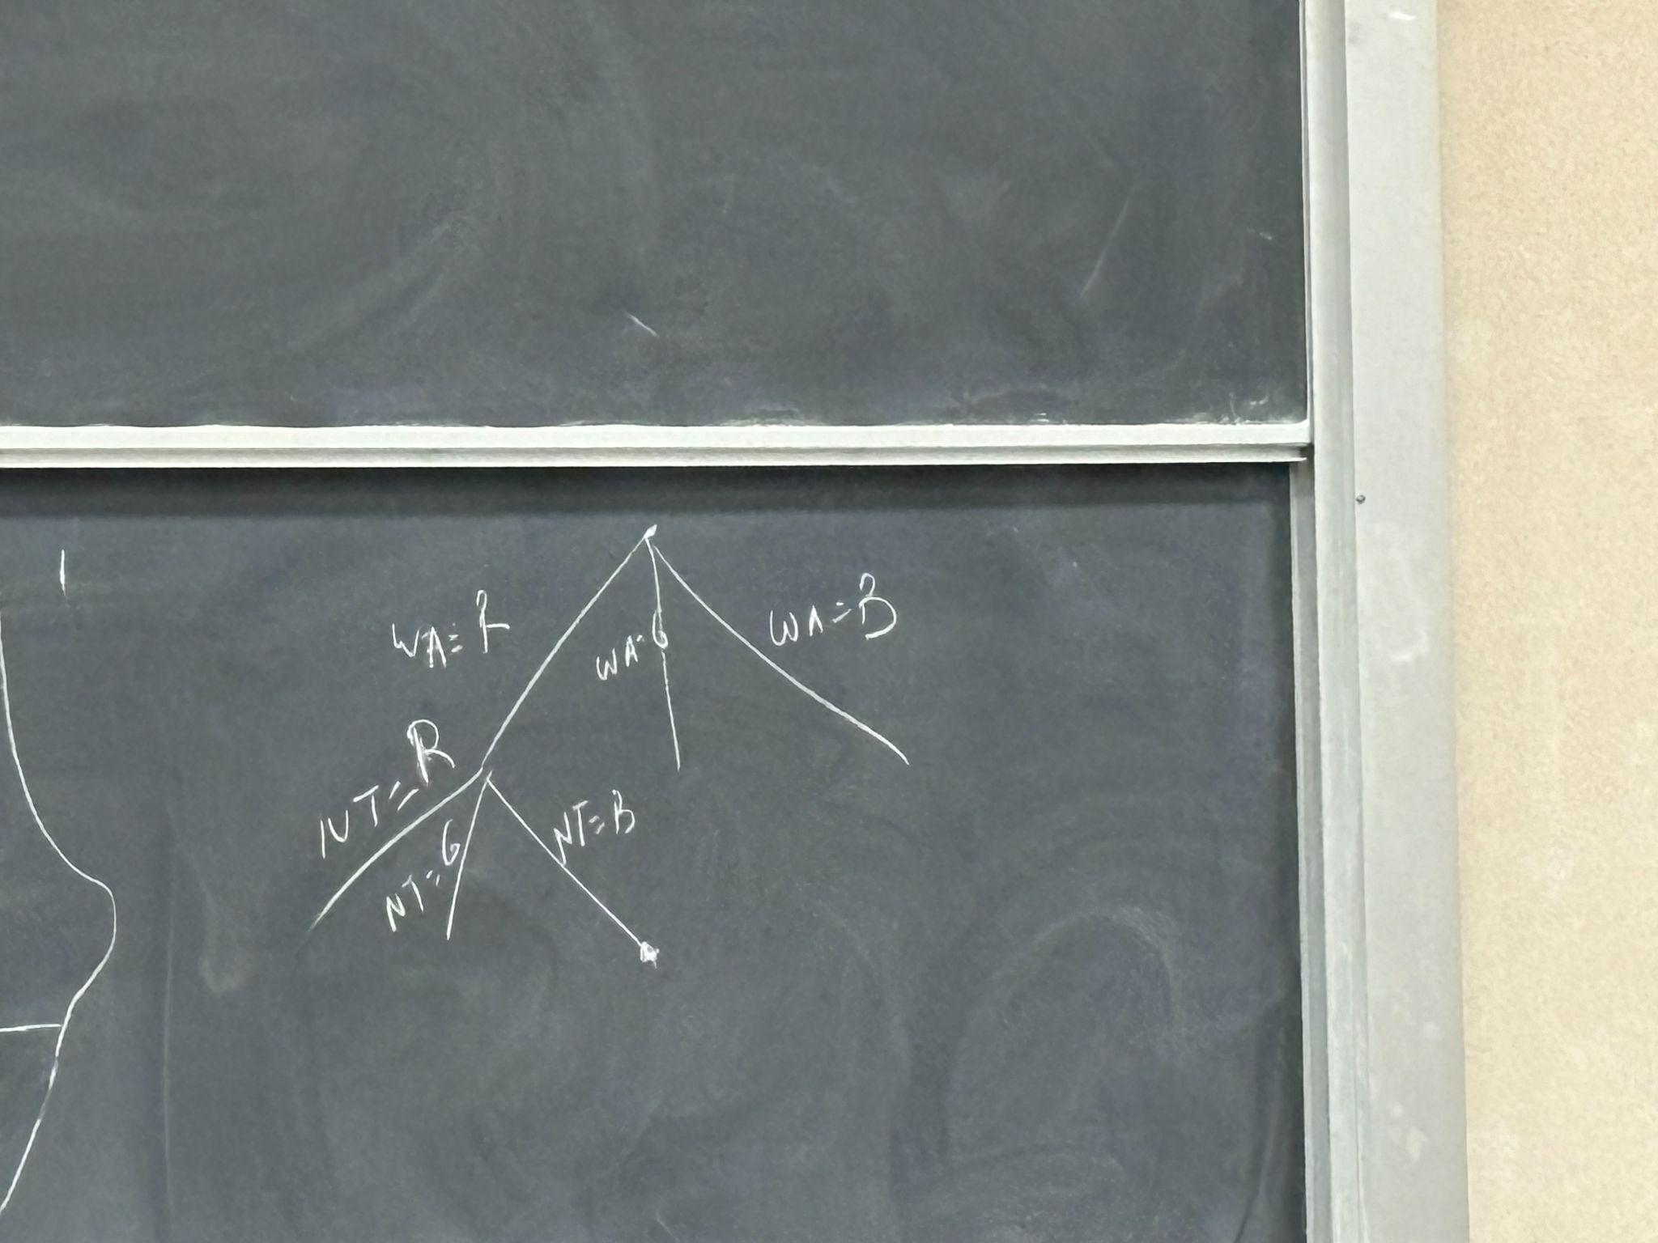
* Helps reduce the branching factor
* Details:
  + Level 0: check individual constraints
  + Level 1: forward checking  
    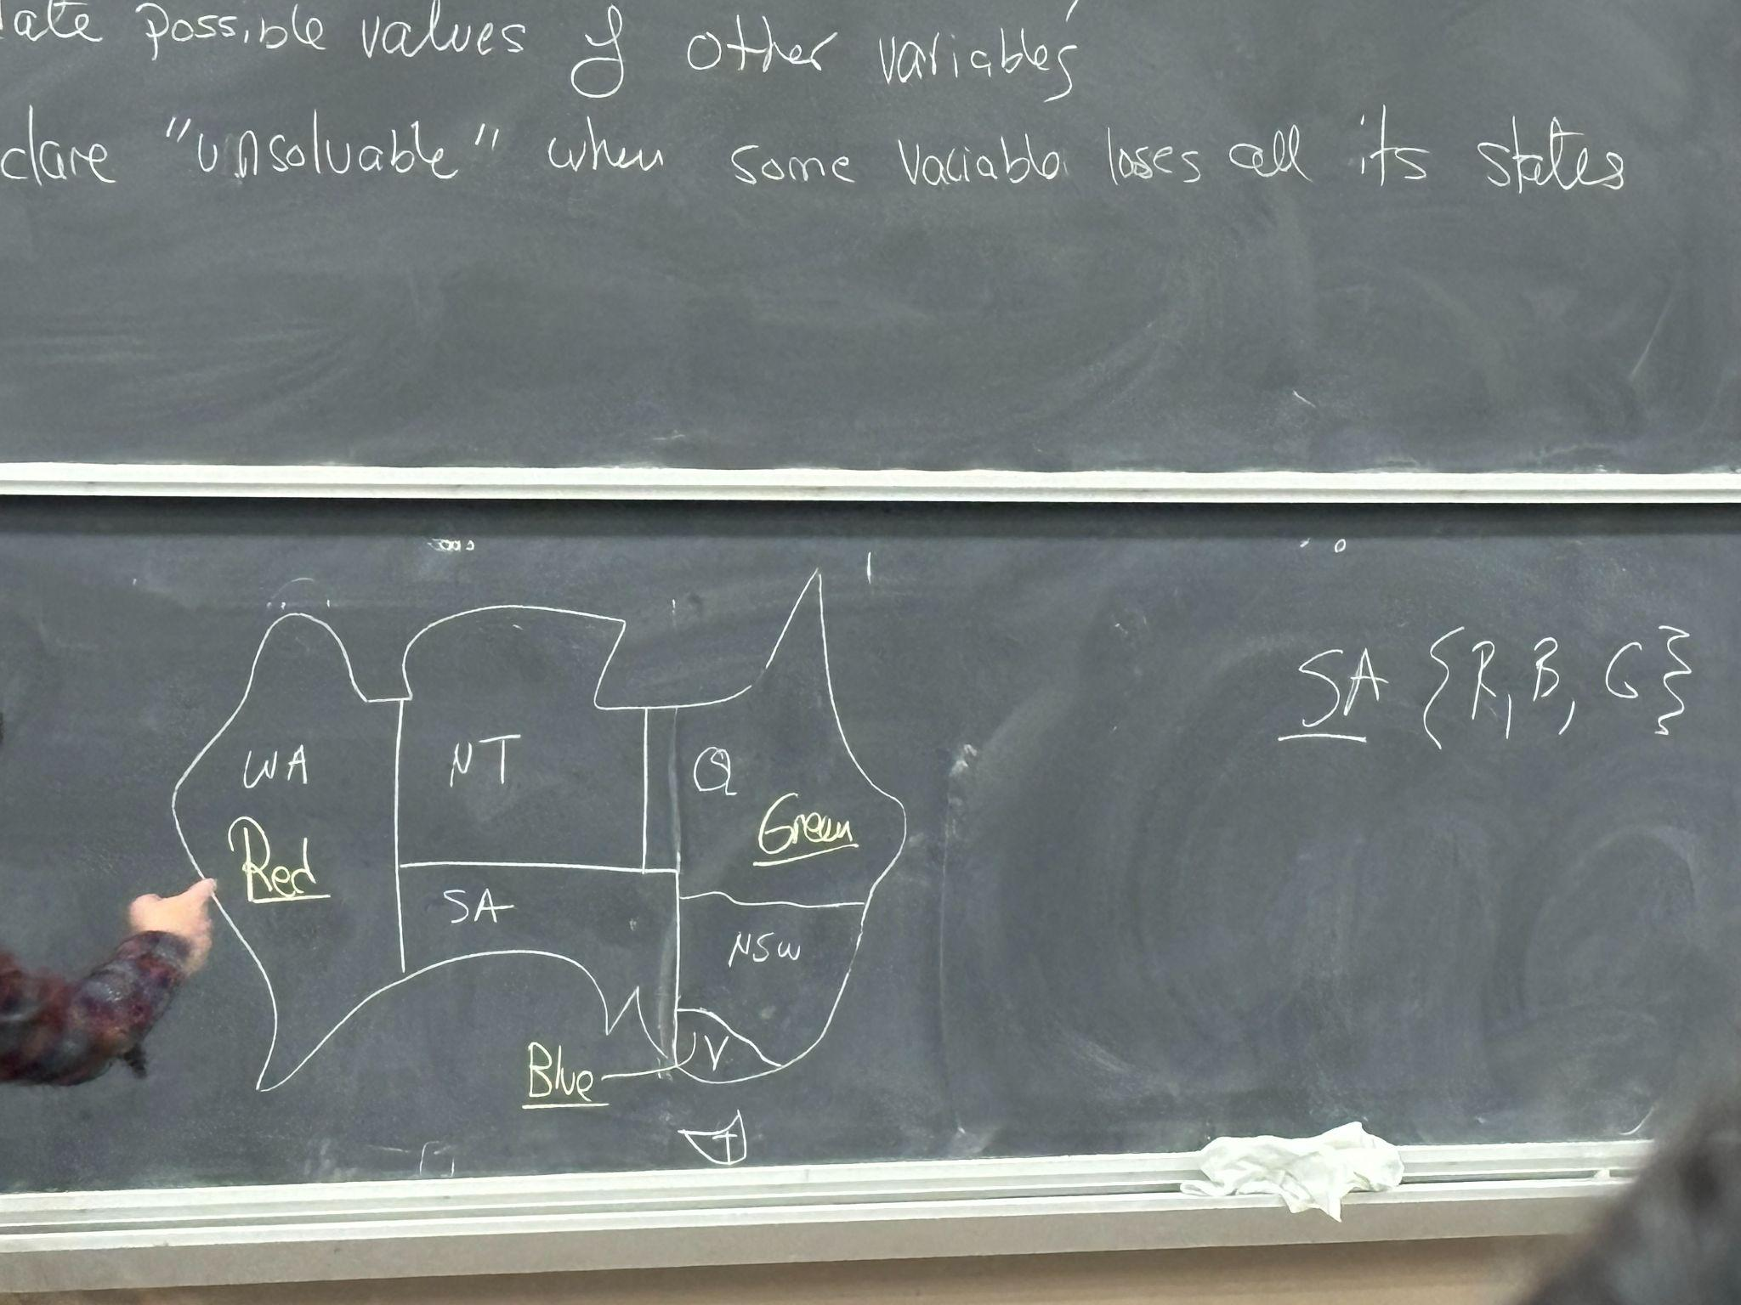
    - Maintain a set of possible values for each variable
    - When you assign a value to a variable, update possible values of other variables
    - Declare “unsolvable” when some variable loses all its states
  + Level 2: Arc consistency
    - Do extra reasoning. If WA is red and Q is Green then both SA and NT must be blue, which is not possible
    - 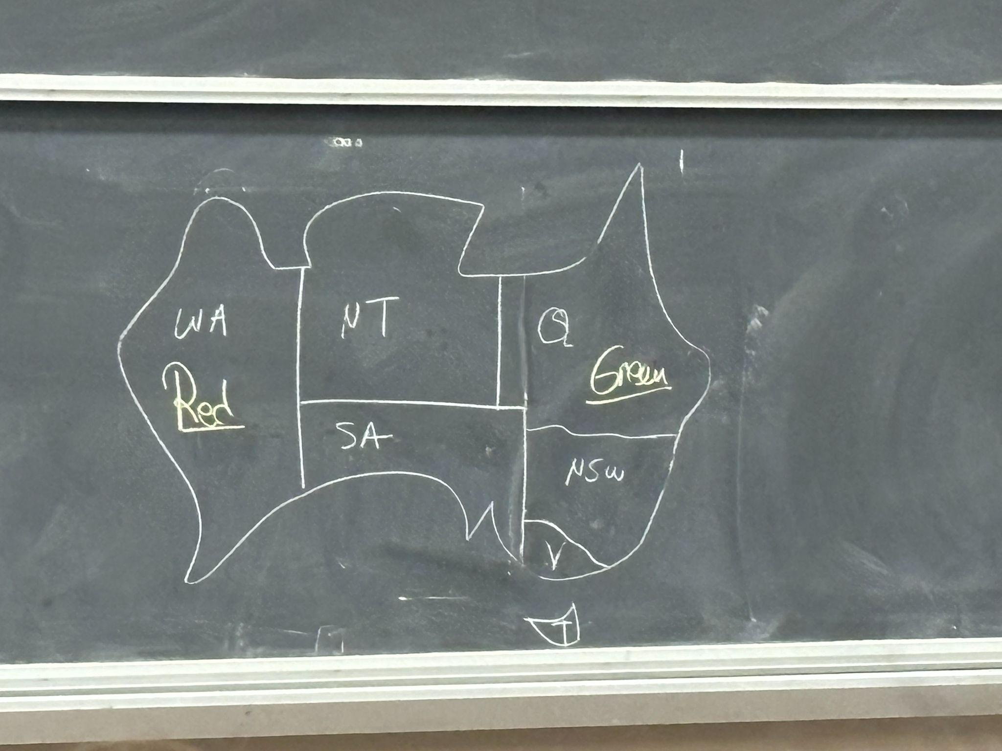
    - **Consistent arc:**
      * An arc x→y is consistent if for every possible value of x there is a compatible value for y
      * 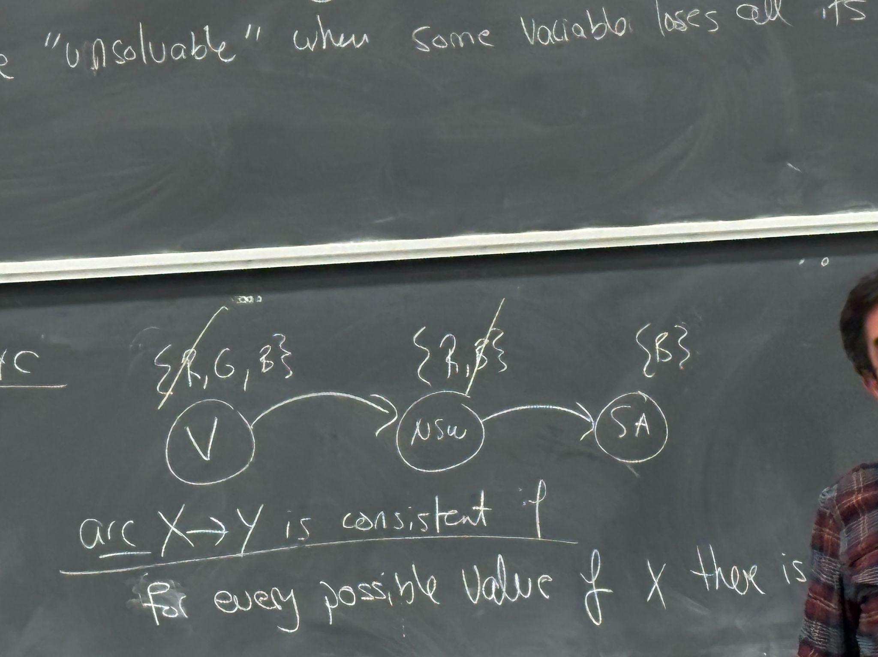
      * complexity : $O(n^{2}d^{3})$
        + Each are costs $d^{2}$, and there are $n^{2}$ arcs, and I can drop at most d values, so i will return at most d values → thus the complexity

# 4/17/2024

Missed first 35 mins - till CSP i think, bounds etc

Branch and bound not in exam syllabus

**Two Player Games**

2 Categories of games

* Perfect Information
  + E.g chess where we can see all pieces on the board from both players
* Imperfect Information
  + E.g card games like poker where we don’t know what the other player has

2 Types of possibilities for probability

* Deterministic
  + clearly defined options/possibilities for moves
* Chance
  + E.g throwing a dice in Backgammon is based on chance and the state itself doesn’t determine possibilities

|  | Deterministic | Chance |
| --- | --- | --- |
| Perfect Information |  |  |
| Imperfect Information |  |  |

* Tic Tac Toe 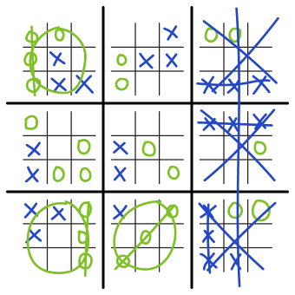

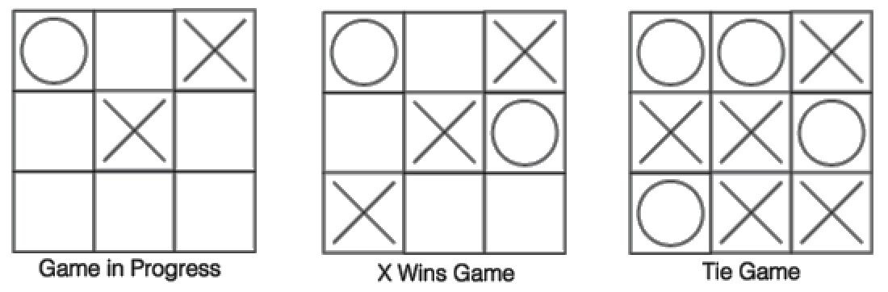

-1 : win for O +1 : win for X 0 : Tie

Search tree -

* IS: empty board
* Terminal states: when either X or O wins (“good states”) or tie

* Until now we had 1 agent, but now we have 2 agents

Game Tree

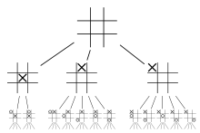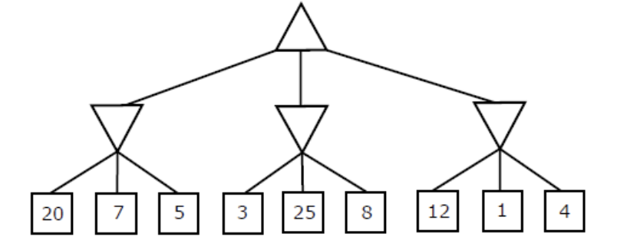

* One player takes an action - Ply
* Another player takes an action - Ply
* Together - Move

Minimax Algorithm:

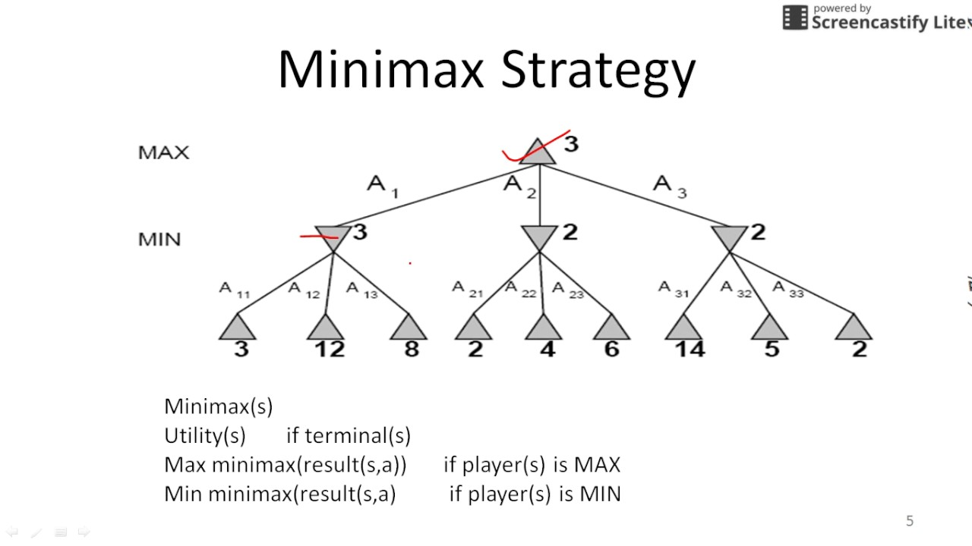

b = branching factor, m = depth of tree

Time - O(b^m)

Space - O(bm)

Mini-max algorithm is a recursive or backtracking algorithm which is used in decision-making and game theory. It provides an optimal move for the player assuming that the opponent is also playing optimally.

* Chess
  + 100 seconds to make move in chess
  + Can expand 10^4 nodes/second
  + Expand 10^6 nodes / 100 s
  + Average branching factor in chess = 35
* In tree when possible moves are
  + m = 4 → 4-ply (novice)
  + m = 8 → 8-ply
  + m =12 → 12-ply
  + one ply corresponds to one level of the game tree

* Evaluate function f(n) → need heuristic

* Alpha-Beta Pruning: It cuts off branches in the game tree which need not be searched because there already exists a better move available. It is called Alpha-Beta pruning because it passes 2 extra parameters in the minimax function, namely alpha and beta.

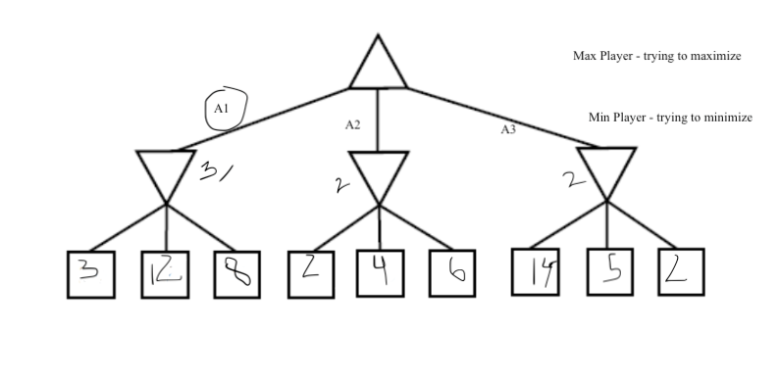

We could have found that A1 was the answer without visiting all the nodes in DFS:

* Can skip 4 and 6 because we have alr found the min in that branch
* If the order for the right most branch was 2 5 14 then we would have seen the 2 first and immediately known to prune but since it is 14 5 2, when we first encounter 14 we continue looking at it’s sibling nodes hoping to find the min of the branch to be greater than 3
* O(b^m/2) with pruning

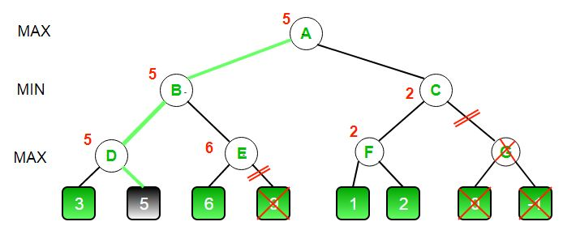

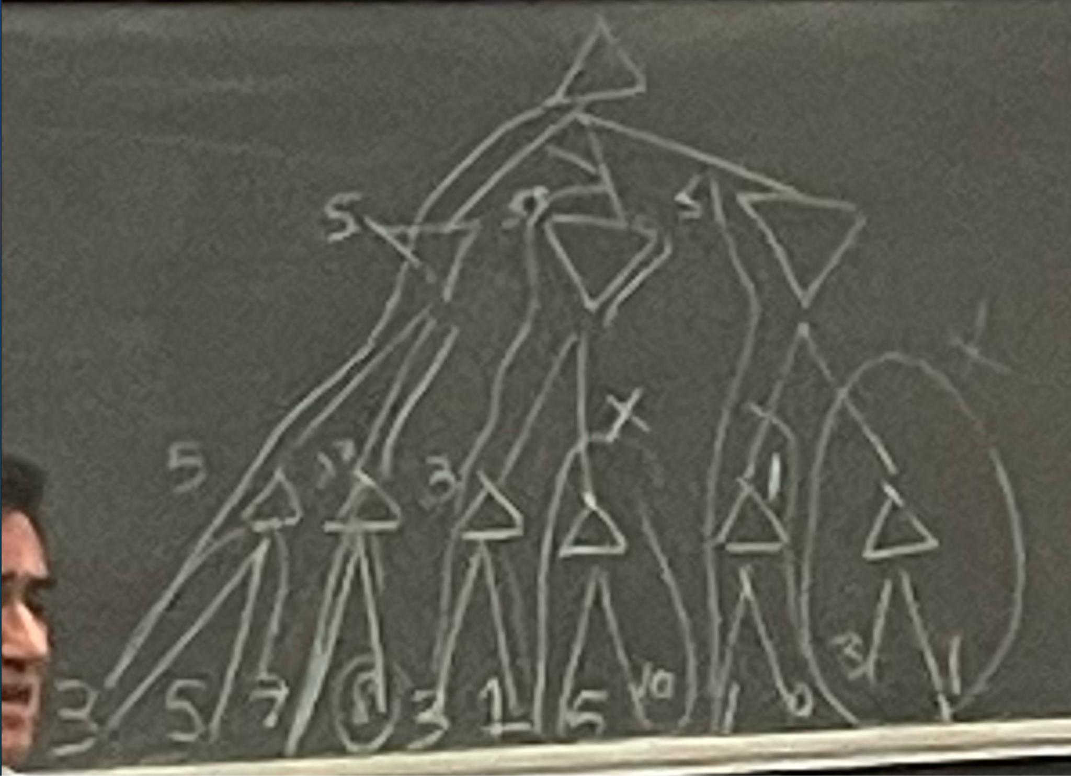

# 4/22/2024

**Knowledge Representation and Reasoning (KR&R)**

*Models*

1. Symbolic (logic)
2. Numeric (probabilistic)
   * Era of AI

**Expert Systems**

* Tools used to build knowledge base

**Common Sense Reasoning**

* Not deductive
* In deduction you make a conclusion, and when given more information the conclusion does not go away

John McCarthy

| Knowledge  Statement in logic (KB = Knowledge base) | → | Reasoning  “deduction” | → Conclusion |
| --- | --- | --- | --- |
|  |  | ↑ Observations |  |

Insert photo1

**Logic**

* Syntax (grammar)
  + Variables : $x_{1},x_{2}....x_{n}$, each having value true/false (1/0)
  + Connectives:
    - ^ : and → S1 ^ S2 is called a conjunction of which S1 and S2 are conjuncts
    - v : or → S1 v S2 is called a disjunction of which S1 and S2 are disjuncts
    - ⇒ : imply
    - ⇔ : equivalent
    - ¬ : not
  + Sentences:
    - Every variable x is a sentence
    - If S is a sentence then ¬S is a sentence
    - If S1, S2 are sentences then S1 ^ S2, S1 v S2, S1 ⇒ S2, S1 ⇔ S2 are all sentences
    - True/False are also sentences → degenerate base cases
    - Example Expression: [[¬(X1 v ¬X3)] ⇒ X4] ^ X5
    - **de Morgan’s Law**:
      * ¬(A ^ B) = ¬A v ¬B
      * ¬(A v B) = ¬A ^ ¬B
    - A ⇒ B = ¬A v B
    - **Contraposition:** A ⇒ B = ¬B ⇒ ¬A
    - Conditions:
      * A ^ False = False
      * A ^ True = A
      * A v False = A
      * A v True = True
    - Example: Insert photo2

(a) is correct

(b) also could work but (a) is stronger and stricter

Insert anmol photo3

* Semantics (meaning)
  + Example: insert preyasi photo4

1. (world) w |= 𝛂 (sentence)
   * + 𝛂 is true at world w (w satisfies 𝛂)
     + 𝛂 : (B v E) ⇒ A = ¬(B v E) v A = (¬B ^ ¬E) v A
       - w1 |= 𝛂 (? validate if true): (¬T ^ ¬T) v T = (F ^ F) v (T) = T
         * So w1 |= 𝛂 is true
       - w2 |= 𝛂 (? validate if true) : (¬T ^ ¬T) v F = F ^ F v F = F
         * So w2 |/= 𝛂 → is not true
2. Mods(𝛂) = { w | w|= 𝛂} [ meaning of 𝛂]

* “Models” of 𝛂
* 𝛂 : (B v E) ⇒ A = ¬B ^ ¬E v A
  + Mods((B v E) ⇒ A) = {1, 3, 5, 7, 8}
* B : 1, 2, 5, 6
* ¬B : 3, 4, 7, 8
* E : 1, 2, 3, 4
* ¬E : 5, 6, 7, 8
* ¬B ^ ¬E : 7, 8
* A : 1, 3, 5, 7
* If we want to find the worlds where 𝛂 is false, find the complement of the worlds where 𝛂 is true
  + **M(¬𝛂) = M(𝛂)’ → complement of M(𝛂)**
  + **M(𝛂 ^ β) = M(𝛂) ∩ M(β)**
  + **M(𝛂 ∪ β) = M(𝛂) ∪ M(β)**
* The Monotonicity of Deductive Logic:
  + If 𝛂 follows from ∆, then 𝛂 follows from ∆^T

| **Semantics**  Properties |  | **Relationships** |
| --- | --- | --- |
| 1. 𝛂 is incoherent/inconsistent iff Mods(𝛂) = Ø |  | 1. 𝛂 “is equivalent to” β iff Mods(𝛂) = Mods(β) |
| 2. 𝛂 is valid/tautology Mods(𝛂) = all worlds |  | 2. 𝛂, β are “mutually exclusive” iff Mods(𝛂) ∩ Mods(β) = Ø |
|  |  | 3. β follows from 𝛂 :   1. Mods(β) ⊆ Mods(𝛂) → if β follows from 𝛂 then β must be a super set of 𝛂 2. M(𝛂) ⊆ M(β) → Correct  * 𝛂 |= β **→** 𝛂 implies/entails β |

**Normal Forms**

* Conjunctive Normal Form (CNF)
* Disjunctive Normal Form (DNF)
* Negation Normal Form (NNF)

**Classical Logic**

* Propositional logic (boolean)
* First-order logic

# 4/24/2024

**Semantics**

* Implication
* Monotonicity and classical logic
* Refutation theorem
* Deduction theorem

**Normal Forms**

* CNF (Conjunctive Normal Form)
* DNF (Disjunctive Normal Form)
* NNF (Negation Normal Form)
* Circuits vs Formulas
* Conversion to CNF

Central Nature

1. w |= 𝛂 (world satisfies sentence)
2. Models(𝛂) = {w | w1 |= 𝛂} (meaning of 𝛂)

* Sentence 𝛂 is inconsistent : M(𝛂) = Ø
* 𝛂, are equivalent : M(𝛂) = M(β)

**Monotonicity**

If 𝛂 |= β then 𝛂^ɣ |= β which gives us

If M(𝛂) ⊆M(β) then M(𝛂^ɣ)⊆M(β) and M(𝛂)∩M(ɣ) ⊆ M(β)

M(𝛂) ∩ M(ɣ) ⊆ M(𝛂) ⊆ M(β)

**Refutation Theorem**

Δ |= 𝛂 iff Δ^¬𝛂 is inconsistent gives us

M(Δ) ⊆ M(𝛂) iff M(Δ^¬𝛂) = ∅

M(Δ) ⊆ M(𝛂) iff M(Δ) ∩ M(𝛂) = ∅

There is no world that satisfies delta but not alpha: If w |= Δ then w |= 𝛂

* |= means satisfies

**Deduction Theorem**

Δ |= 𝛂 iff Δ ⇒ 𝛂 is valid

M(Δ) ⊆ M(𝛂) iff M(Δ⊆𝛂) = the set of all worlds

Note, M(𝛂 ⇒ β) = M(¬𝛂 v β)

**Normal Forms**

Literals {X: positive literal, Y: negative literal}

**CNF**

* Disjunction of literals = “clause” → underlined
* Eg. (A v ¬B) ^ (B v ¬C v ¬D) ^ (¬B v D) ^ …. → conjunction of clauses
* Hard to solve problems (NPcomplete) → can’t be solved in poly time if more than 2 literals

**DNF**

* Conjunction of literals = “term” → underlined
* Eg. (A ^ ¬B) v (A ^ ¬C) v (A ^ ¬D ^ ¬E) v…. → disjunction of terms
* Easier to solve than CNF

**Horn Clause**: a clause with at most one positive literal

**NNF**

* Can only use the following connections: ^, ∨,¬
* Negations can only appear next to the variables
* CNF and DNF are subsets of NNF
* **Properties:**
  + Decomposable (D) NNF - if 𝛂^β appears in an NNF, then vars(𝛂) ∩ vars(β) = ∅ → should not share variables
    - Eg (A∨∨B) ^ (¬B ∨ D) → not NNF decomposable because underlined terms share var B
    - Eg. (A ∨ B) ^ (C ∨ ¬D) → is decomposable
    - The tree drawn below is decomposable! → DNNF
    - If it is decomposable, satisfiability can be done in linear time
    - Universal
  + Deterministic (d) NNF - if 𝛂∨β appears in an NNF, then 𝛂^β is inconsistent → 𝛂 and β must be mutually exclusive
    - Eg. (A∨B) ^ C → is decomposable, but not deterministic as A and B are not mutually exclusive necessarily
    - Eg. ((A ^ ¬B) ∨ B) ^ C → is decomposable and deterministic as (A ^ ¬B) and B are mutually exclusive
    - The tree drawn below is deterministic! → d-NNF
    - Deterministic is interesting only with decomposability
    - Universal

Is the normal form “universal” (i.e can any sentence be converted to that form)?

* CNF is universal - anything can be rep’d as a CNF
* DNF is universal - anything can be rep’d as a DNF
* NNF is universal - anything can be rep’d as a NNF
* Horn CNF is not universal

**Circuits vs Formulas**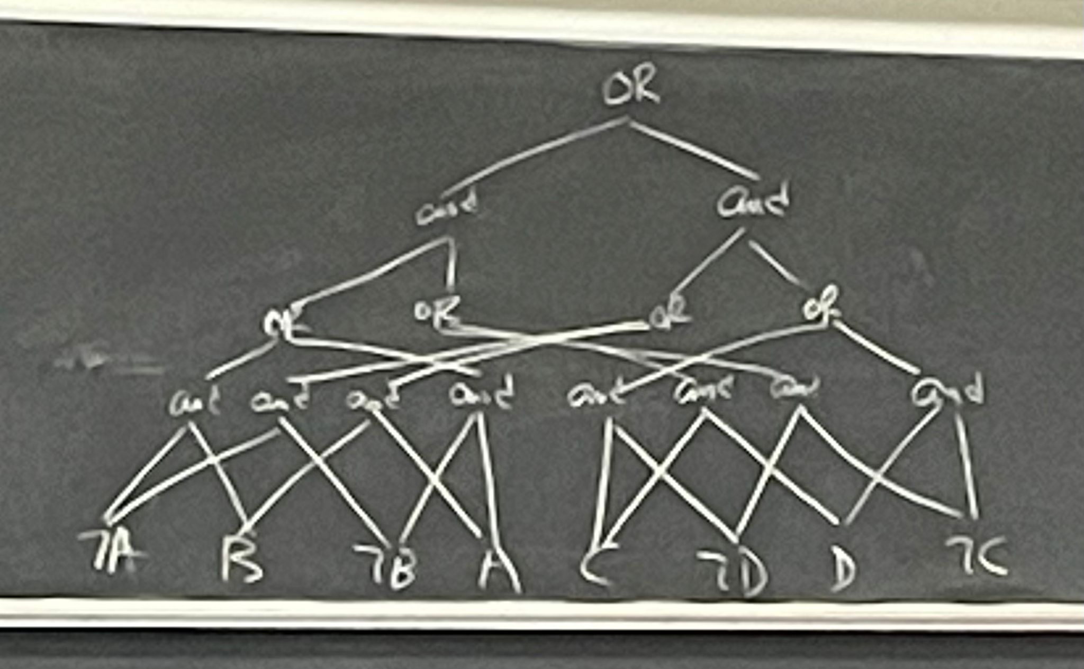

Circuit representation of a formula:

This example specifically is a NNF circuit. It is decomposable and deterministic. → d-DNNF

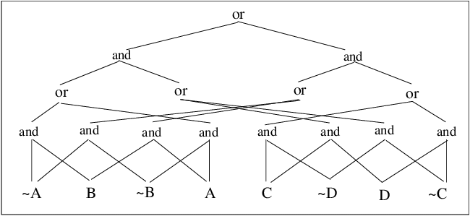

**Conversion of Sentences to CNF**

1. Get rid of all connectives but for ^, ∨, ¬
   1. 𝛂 ⇒ β → ¬𝛂 v β
   2. 𝛂 ⇔ β → (𝛂 ⇒ β) ^ (β ⇒ 𝛂)
2. Use de morgan’s law to push negations inward
   1. ¬(𝛂^β) → ¬𝛂 ∨ ¬β
   2. ¬(𝛂∨β) → ¬𝛂 ^ ¬β

* E.g. insert photo

# 4/29/2024

**Propositional Logic (so far)**

* Syntax
* Semantics
* Normal Forms
  + CNF (Horn)
  + DNF
  + NNF
    - Decomposability
    - Determinism
  + Formula vs Circuits

**Inference**

* Given:
  + Knowledge Base: ∆ = { β1, β2, β3…. Βn} = β1 ^ β2 …. ^ βn
  + Query: 𝛂
* Does ∆ imply 𝛂?
  + Notation: ∆ |= 𝛂 ?
  + M(∆) $⊆ M(α)$
* How to solve it?
  + **Model enumeration** 
    - M(∆) $⊆ M(α)$
  + **Inference Rules**
    - “Resolution”
  + By reduction to SAT (Satisfiability) - CSP Techniques
    - DFS/Backtrack
    - Local Search

**Method 1: Model Enumeration**

Example:

KB ∆ = {A, A v B ⇒ C} == (A) ^ (A v B ⇒ C)

¬(A v B) v C

¬A ^ ¬B v C

𝛂 = C

Then ∆ |= 𝛂?

|  | A | B | 𝛂 = C | ¬A ^ ¬B v C | ∆ |
| --- | --- | --- | --- | --- | --- |
| 1 | T | T | T | T | T |
| 2 | T | T | F | F | F |
| 3 | T | F | T | t | T |
| 4 | T | F | F | F | F |
| 5 | F | T | T | T | F |
| 6 | F | T | F | F | F |
| 7 | F | F | T | T | F |
| 8 | F | F | F | T | F |

M(∆) = {1,3}

M(𝛂) = {1,3,5,7}

—---------------------

M(∆) $⊆ M(α)$

Hence, ∆ |= 𝛂

* Equivalence: 𝛂 equivalent β
  + M(𝛂) = M(β)
* Validity:
  + M(𝛂) = W (set of all worlds)

**Method 2: Inference Rules**

Usually represented as: $\frac{Pattern 1, Pattern2}{Pattern 3 }$

* Means if pattern1 and pattern2 then feel free to add pattern3
* Examples:

These are all sound!

* + (Modus Ponens)
    - If 𝛂 $∈∆$ and 𝛂 ⇒ β $∈$ ∆, then add β to ∆
  + $\frac{ α => β, ¬β }{ ¬α}$ (Modus Tollens)
  + $\frac{ α }{ α v β }$ (OR - introduction)
* **Inference Rule Soundness** of R (Correct)
  + If ∆ $|-_{R}$ 𝛂 then ∆ |= 𝛂
    - If I can derive 𝛂 from ∆, then 𝛂 must logically follow from ∆
* Example 2:
  + Suppose, we know:

∆ = {X ⇒ Y, Y⇒ Z}

𝛂 = (X ⇒ Z)

—-----------------------

Indeed, ∆ |= 𝛂

* + Doing this by Modus Ponens,
    - We can't, because even though we have X ⇒ Y $∈$ ∆, we don’t have X $∈∆$
    - Thus Modus Ponens is not complete
* **Completeness of Inference Rule R**
  + If ∆ |= 𝛂, then ∆ $|-_{R}$ 𝛂
    - If 𝛂 logically follows from ∆, then I must be able to derive 𝛂 from ∆
* **Inference Rule of Resolution**
  + Normally applies to CNF
    - Example 3:   
      Classic CNF: (A v ¬B) ^ (¬A v C v ¬D) ^ (B v ¬D v X) == {{A, ¬B}, {¬A, C, ¬D}, {B, ¬D, X}}
    - Apply Resolution here we get: $\frac{\{A, ¬B\} , \{¬A, C, ¬D\}}{\{¬B C, ¬D\}}$
      * “*We resolved clause 1 with clause 2 on Variable A*”
      * The denominator is the “***Resolvent***”
  + Resolution: $\frac{X v α , ¬X v β}{α v β}$
    - X is **positive literal**
    - $¬X$ is **negative literal**
    - Example:
      * + Falsehood → {}
        + “*Empty clause*”
      * ∆ = {X, $¬$ Z}

𝛂 = X v $¬$ Y

—------------------

∆ |= 𝛂 (Cannot do using resolution!)

* + Resolution is “**refutation**” complete when applied to CNF
    - Will give the empty clause if the sentence is false
  + **Refutation Theorem**
    - ∆ |= 𝛂 iff ∆ ^ $¬$ 𝛂 is inconsistent
      * If we find a contradiction ∆ |= 𝛂 holds
      * If we don't find the contradiction then ∆ |= 𝛂 does not hold
  + Example 4:

∆ = { A v $¬$ B ⇒ C, C ⇒ D v $¬$ E, E v D}  
𝛂 = A ⇒ D

| CNF | $¬$ 𝛂: $¬$ (A⇒D) |
| --- | --- |
| A v $¬$ B ⇒ C → ($¬$ A v C) ^ (B v C) | $¬$ ($¬$ A v D) |
| C ⇒ D v $¬$ E → $¬$ C v D v $¬$ E | A ^ $¬$ D |
| E v D → E v D | A ^ ($¬$ D) |

|  |  |  |
| --- | --- | --- |
| ∆ | 0 | {$¬$ A, C} |
|  | 1 | {B, C} |
|  | 2 | {$¬$ C, D, $¬$ E} |
|  | 3 | {E, D} |
| $¬$ 𝛂 | 4 | {A} |
|  | 5 | {$¬$ D} |

6 {C} (*Unit Clause*) 0,4

7 {D, $¬$ E} 2, 6

8 {$¬$ E} 5,7

9 {D} 3,7

10 {E}

11 {} 8, 10

12 {} 5,9

Resolution proof

Notation (contd.)

* ∆ |= 𝛂 : 𝛂 logically follows from ∆
  + ∆ implies 𝛂
  + ∆ entails 𝛂
  + ∆ satisfies 𝛂
* ∆ $|-_{R}$ 𝛂 : 𝛂 can be derived from ∆ using inference rule R

Converting to CNF

* A v B ⇒ C → ($¬$ A v C) ^ (B v C)

# 5/6/2024 (First Order Logic Part I)

**First Order Logic**

* Sometimes called First Order Logic (FOL), Predicate Calculus (PC)
* More expressive, and succinct (more compact) than propositional logic
* Example 1:   
  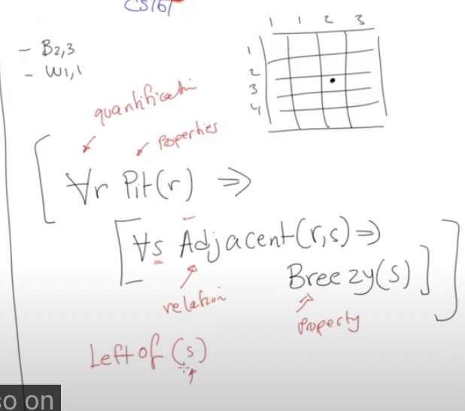  
  For all squares r, if there is a Pit in r, then all adjacent cells to r will be breezy
* **World (in FOL):**
* *(these categories are mutually exclusive, but there are more than one way to specify these things)*
  + **Objects**
    - People, houses, wumpus, numbers, colors…
  + **Properties**
    - Breezy, large, red …
  + **Relations**
    - Inside, adjacent, larger …
    - Holds between objects
    - Maps to t/f
  + **Functions**
    - Father of, best friend of…
    - Maps object to object
    - age(sally) → number
* Example 2: One plus one equals two  
  Objects: one, two   
  Relations: equals  
  Functions: plus  
  Properties: -
* Example 3: Squares adjacent to the wumpus are smelly   
  Objects: Wumpus, Squares  
  Relations: Adjacent  
  Functions: -   
  Properties: smelly
* **Syntax**
  + **Constants**: 2, jack, UCLA…
  + **Predicates**: adjacent,...
  + **Functions**: left of…
  + **Variables**: x, y, z…
  + **Connectives**: ^ , v, ¬, ⇒ , ⇔
  + **Equality**: =
  + **Quantifiers**: ∀, ∃
  + **Atomic Sentences** 
    - **Term** 
      * Expression to refer to an object
      * Constant or variable or apply a function
      * Example: Fatherof(Jack) is a term
    - Definition: Predicate(term1, term2,... termn)
    - Examples:
      * Brother(Jack, Tom),
      * Brother(Fatherof(Jack), Tom)
  + **Universal Quantifier** ∀(for all)
    - ∀<variables><sentence>
    - ∀x at (x, UCLA) ⇒ Smart(x)
      * Predicates: At (relation), Smart(property)
      * Constant: UCLA
      * Statement meaning: “*everyone at UCLA is smart*”
      * Equivalent to conjunction of all instantiations of P
  + **Existential Quantifier** ∃ (there exists)
    - ∃<variable><sentence>
    - ∃x at (x, UCLA) ^ Tall(x)
      * Means: “*someone at UCLA is tall*”
      * Disjunction of instantions
  + **Properties of Quantifiers**
    - ∀x∀y same as ∀y∀x
    - ∃x∃y same as ∃y∃x
    - ∃x∀y is not the same as ∀y∃x
      * Example: let’s take the sentence
        + ∀y∃x loves (x,y): *everyone in the world is loved by at least one person.* The bracket means (x loves y).
        + ∃x∀y loves (x,y): *there is a person who loves everyone in the world*
  + **Rewriting Sentences**
    - ∀x likes(x, IceCream) is the same as ¬(∃x ¬likes(x, IceCream))

# 5/8/2024 (First Order Logic Part II)

**Equality**

* Special Predicate
* Example1: Spot has two sisters
  + Predicate: sister
  + Constant: spot
  + Statement: ∃x ∃y Sister(x, Spot) ^ Sister(y, Spot) ^ ¬(x = y)
* Example 2: Spot has exactly two sisters
  + Statement: ∃x∃y(sisters(x,Spot)∧sisters(y,Spot)∧ x $≠$ y ∧∀z((sisters(z,Spot)⇒(z=x∨z=y))))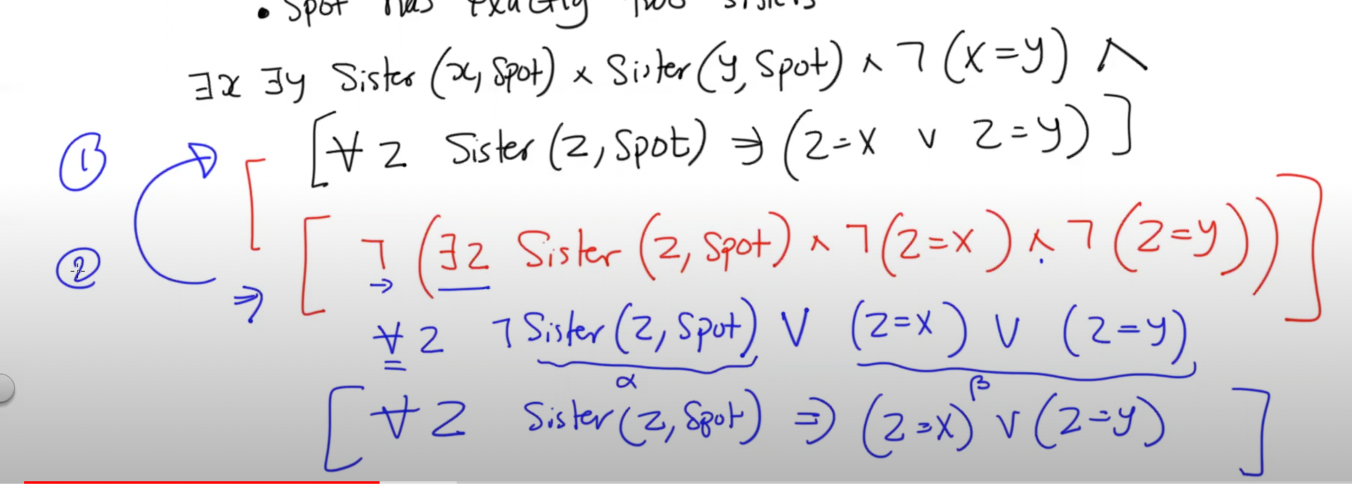

**Uniqueness Quantifier** (∃!)

* Example: ∃!x king(x)
  + *There exists exactly one king*
  + Rewriting this: [∃x king(x) ^ [∀y king(y) ⇒ (x = y)]]
    - *There exists a king x, and for all y if y is king then this implies that x = y*

**Points to remember**

* **Well-formed**
  + Expression with no free variables. Avoid having free variables, i.e. variables without quantifiers
* Avoid having ∃ and ∀ as a subset of the other
  + Example: ∀x [cat(x) v (∃x Brother(Rich, x))]

| Propositional Logic | First Order Logic |
| --- | --- |
|  |  |

Example 1:

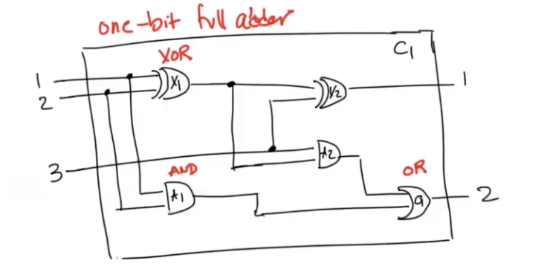

Knowledge Base:

* Independent of this circuit (domain)
* This circuit (instance)

Queries:

* 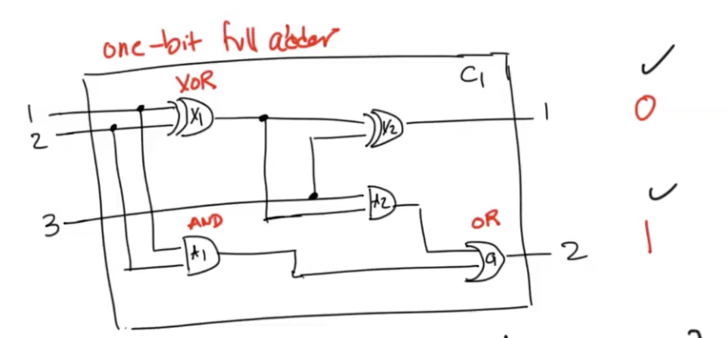
* If I had the following assignment at the end, what inputs would I have?

**Properties**

* Vocabulary:
  + Constants, functions, predicates
* Constants:
  + AND, OR, NOT, XOR
  + 0, 1
  + X1, X2, A1, A2, O1
* Functions:
  + Type, Signal, In, Out
* Predicate:
  + Connected

Component 1:

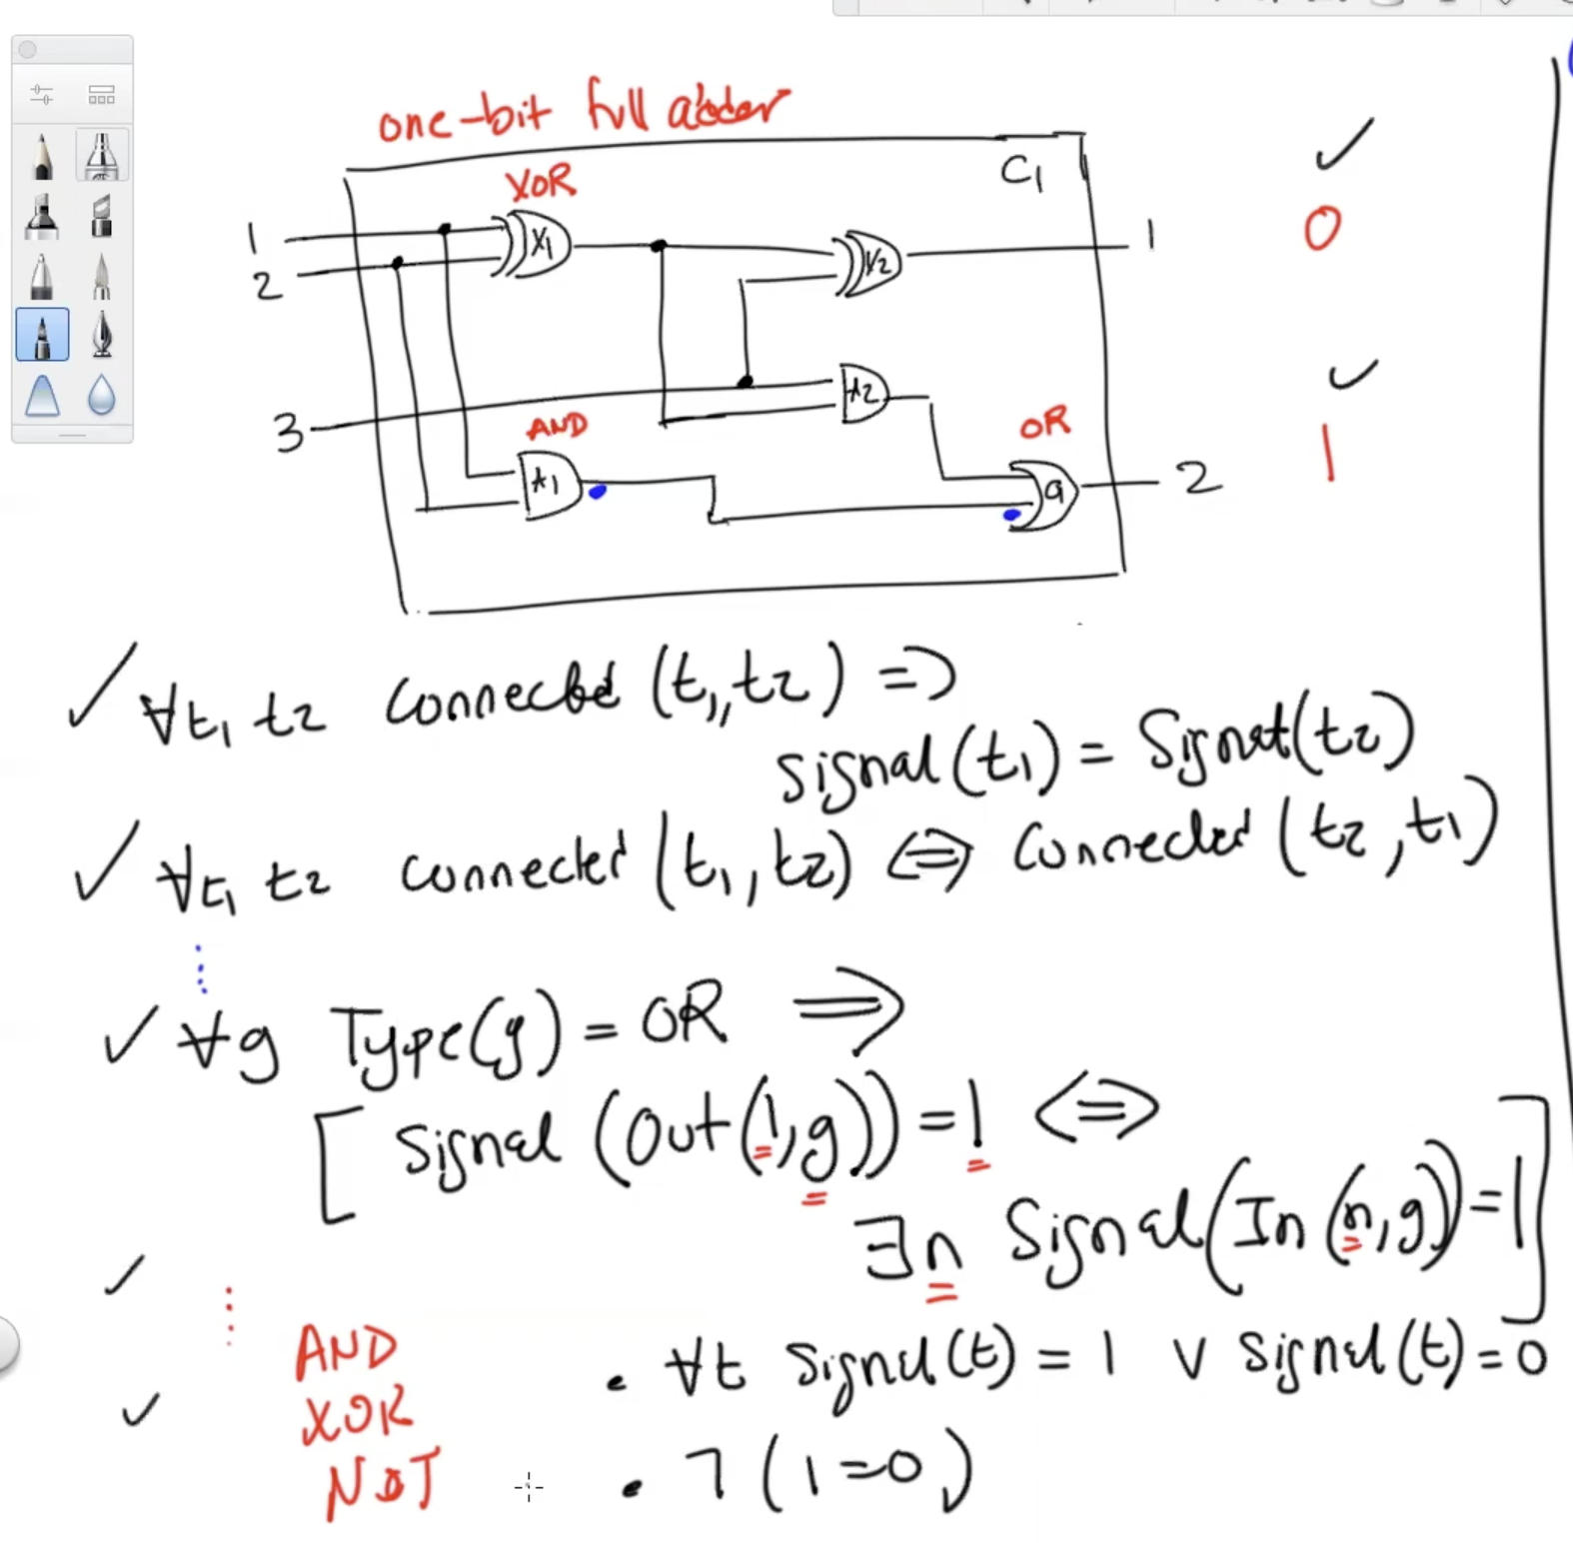

Component2:

* Type(X1) = XOR, Type(X2) = XOR … Type(O1) = OR
* Connected(Out(1, X1), In(2, A2)) …

Query:  
 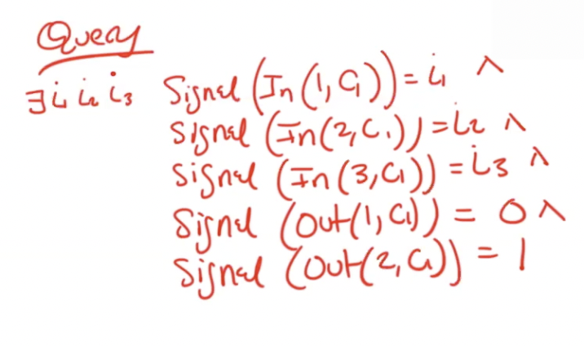  
  
Solution:

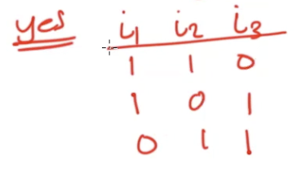

# 5/13/2024

From Piazza: <https://cdn-uploads.piazza.com/paste/ky3joonnxy74iv/6f3fcce40b5676aba20e756242a41ec111b0ee6cdb3dfe94a309580d43d61b3b/05-13-week-07-mon.txt>

# 5/15/2024

**Classical Logics**

**Non-Classical Logics**

* We don’t just talk about facts, but also introduce assumptions.
* Idea: *let’s not talk about whether something is true/false, or that it is a fact/assumption, let’s talk about the probability.*

Example1:

Probability Distribution (State of Belief)

| World | E (Earthquake) | B (Burglary) | A (Alarm) | P(.) | P(. | A)  *Zero out where A is False*  *Where A is True, normalize the P(.)/P(A)* |
| --- | --- | --- | --- | --- | --- |
| W1 | T | T | T | 0.019 | 0.0778 |
| W2 | T | T | F | 0.001 | 0 |
| W3 | T | F | T | 0.056 | 0.2293 |
| W4 | T | F | F | 0.024 | 0 |
| W5 | F | T | T | 0.162 | 0.663 |
| W6 | F | T | F | 0.018 | 0 |
| W7 | F | F | T | 0.0072 | 0.02948 |
| W8 | F | F | F | 0.7128 | 0 |

**Bayesian Network** (*Graph that represents causality*)

We synthesized our numbers from this.

E B

\ /

A

If ∆: E v B ⇒ A then this knocks off certain worlds as impossible

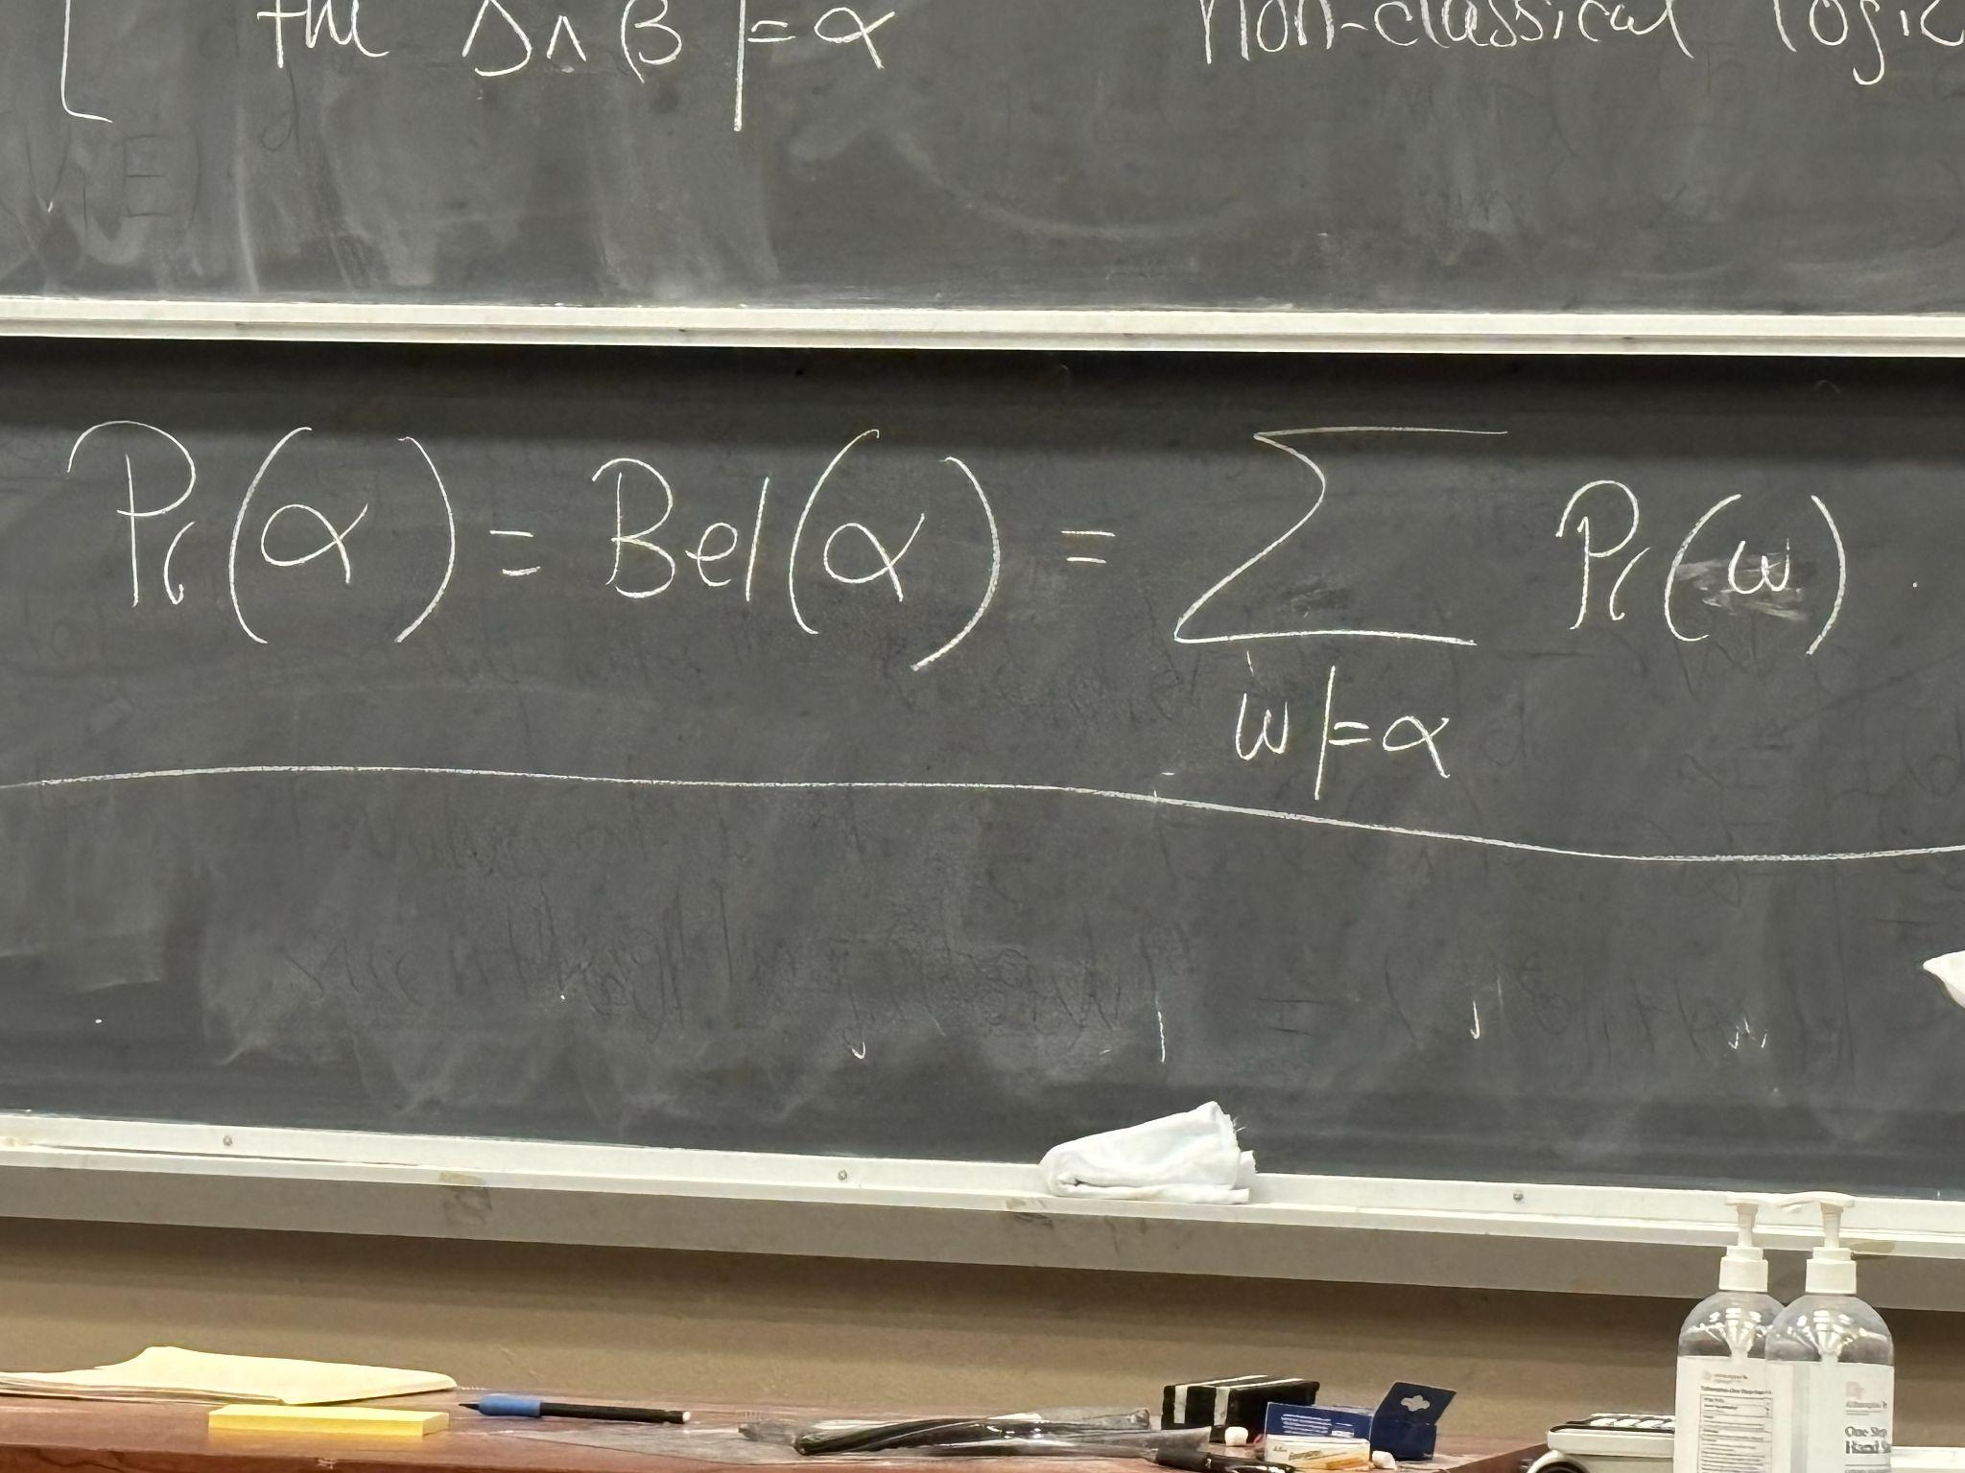

We get the following probabilities by adding up where the variables are true:

* P(E) = 0.1
* P(¬B) = 0.8
* P(A) = 0.2442

**Properties**

* Sentence 𝛂: $0≤P(α)≤1$
* 𝛂 is inconsistent: P(𝛂) = 0
* 𝛂 is valid: P(𝛂) = 1
* P(𝛂) + P(¬𝛂) = 1
* P(𝛂 v β) = P(𝛂) + P(β) - P(𝛂 ^ β)
  + P(𝛂 v β) = P(𝛂) + P(β) if 𝛂, β are mutually exclusive

How do you change your mind in this setting?

* If you have a traditional knowledge base like this:   
  ∆ = 𝛂1, 𝛂2, 𝛂3…, 𝛂n, 𝛂n+1
* **Evidence**
  + The alarm triggered in Example1.
  + We need to have a new distribution now, in light of the evidence
    - Original Distribution: P( . )
    - Evidence β
    - New Distribution: P( . | β) ← conditions
  + 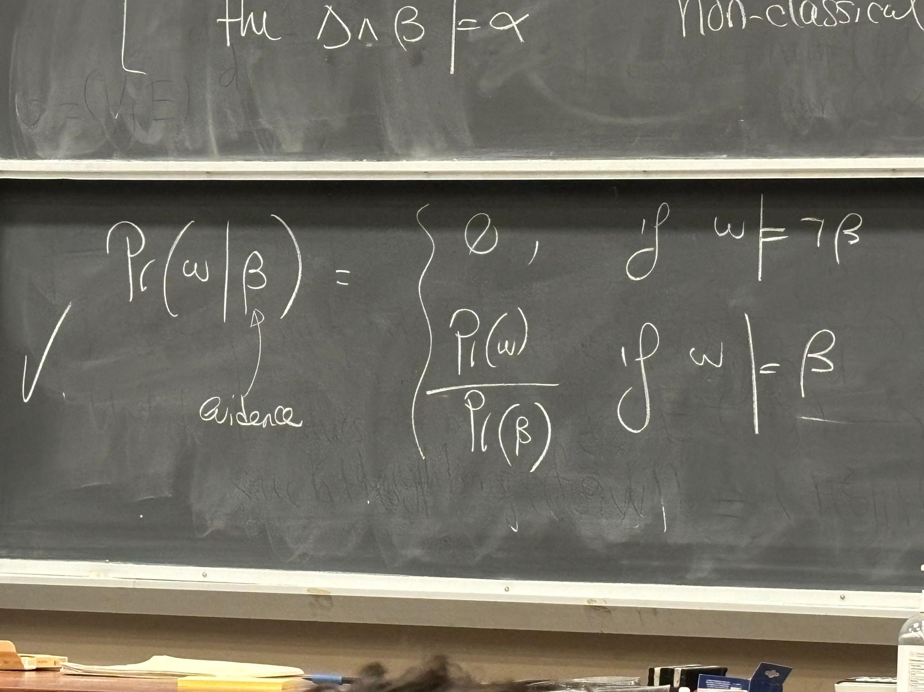

**Bayes Conditioning**

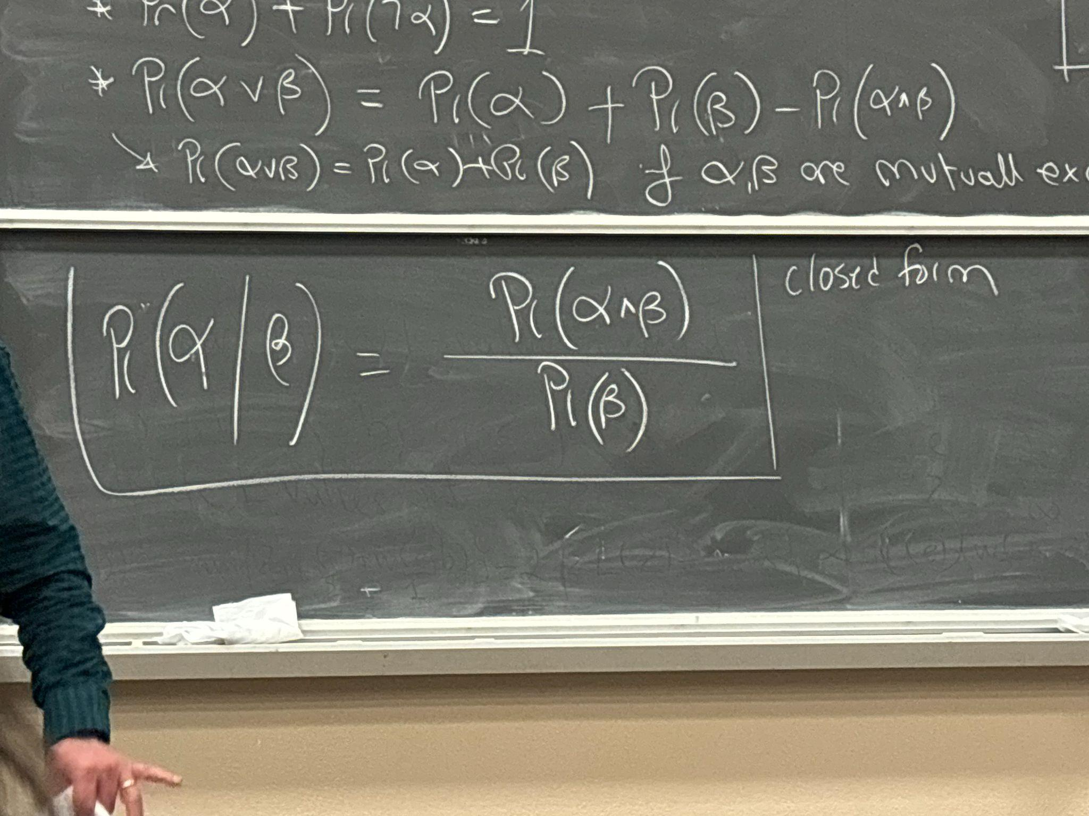

Example 2:   
Suppose,

| P (B) = 0.2 | P(E) = 0.1 | P(E) = 0.1 | P(B) = 0.2 |
| --- | --- | --- | --- |
| P(B | A) = 0.741 *(Increases)* | P(E | A) = 0.307 *(increases)* | P(E | B) = 0.1 | P(B | E) = 0.2 |
| P(B | A, E) = 0.253 *(Decreases from the above, because there is reason for alarm)* |  |  |  |
| P(B | A, ¬E) = 0.957  *(The number goes even higher)* |  |  |  |

*Burglary is a stronger cause for Alarm.*

**Independence**

* 𝛂 is independent of β
* P(𝛂 | β) = P(𝛂)
* P(𝛂^β)/P(β) = P(𝛂)
* P(𝛂^β) = P(𝛂) x P(β)

**Conditional Independence**

* 𝛂 is independent of β given ɣ
* P(𝛂 | β, ɣ) = P(𝛂 | ɣ)
* P(𝛂, β | ɣ) = P(𝛂 | ɣ) x P(β | ɣ)

**Case Analysis aka Law of Total Probability**

* P(𝛂) = ∑ P(𝛂, βi) β1, β2, … are mutually exclusive and exhaustive

i = 1 to n

= ∑ P(𝛂, βi) P(βi)

i = 1 to n

* P(𝛂) = P(𝛂 | β) P(β) + P(𝛂 | ¬β) P(¬β)

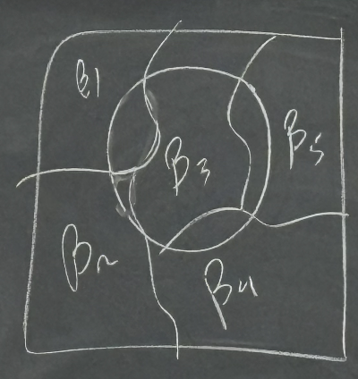

**Bayes Rule/Theorem**

* P(𝛂 | β) = P(β | 𝛂) P(𝛂) / P(β)
* 𝛂 = cause, β = effect → P(𝛂 | β) is harder to compute
* But P(β | 𝛂) is effect given cause which is easier to compute and can help find P(𝛂 | β)

Example:

* Disease: 1/1000
* Test: 5% false negative rate, 2% false positive rate
* What is the belief that given a positive test result, the randomly chosen person has the disease?
* Variables: D = has disease, ¬D = does not, T = tested positive, ¬T = tested negative
* Translate info we have:
  + P(D) = 0.001
  + P(¬T | D) = 0.05 → P(T | D) = 0.95
  + P(T | ¬D) = 0.02 → P(¬T | ¬D) = 0.98
  + P(D | T) ⍺ ?
* Using Bayes Rule: P (D | T) = P(T | D) P(D) / P(T) = 0.95 x 0.001 / P(T)
* Using Case Analysis: P(T) = P(T | D) P(D) + P(T | ¬D) P(¬D) = 2093/100,000
* Plugging it in: P(D | T) ≈ 4.5%

# 5/20/2024

* Probability as a basis for beliefs (foundations)
* Modeling Bayesian Networks
* Inference (reasoning)
* Learning

**Modeling Bayesian Networks** → Causal Graph – state of belief → Probability Distribution

* Variable X
* Value x
* A set of variable X instantiation x
  + A = {x, y} a: x = r, y = l

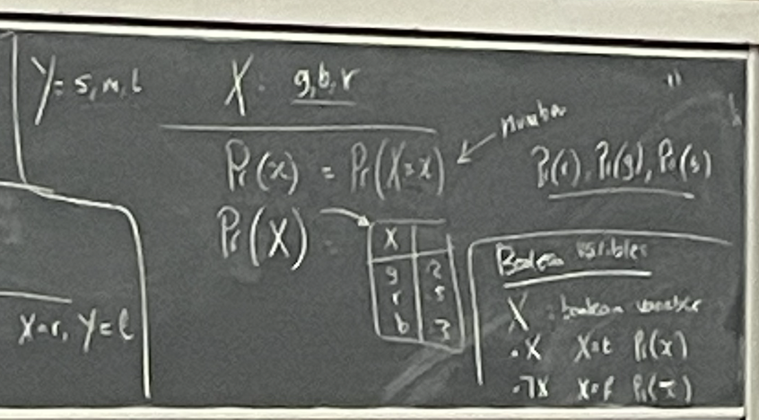

**Independence**

* P(𝛂 | 𝜷, Ɣ) = P(𝛂 | Ɣ) → 𝛂 is independent from 𝜷 given Ɣ
* 𝛂, 𝜷, Ɣ → sentences/events
* I (X, Z, Y) → X is independent of Y given Z
* P(x | y, z) = P(x | z) for all x, y, z
  + X = {A, B}
  + Y = {C}
  + Z = {D, E}
    - a ^ b : independent of c given d, e
    - a ^ not b : independent of c given d, e
    - not a ^ not b : independent of not c given not d, not e
    - ^ 32 possibilities

**Capturing Independence Graphically**

* Causal graph v

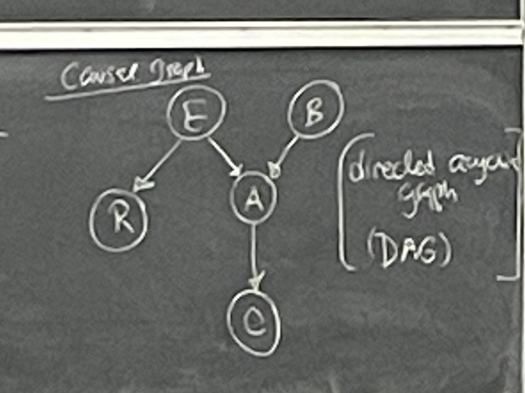

Parents(v)

* A: B, E
* R: E
* C: A

Descendants(v):

* E: A, C, R
* B: A, C
* C: 𝜙

Non-descendants(v):

* Evaluate v and its parent
* A: R
* E: B
* C: B, E, R

For every variable/node v in a causal graph:

* I (v, Parents(v), Non-descendants(v))
  + I (C, A, BER) = I(C, A, {B, E, R})
  + I (R, E, ABC)
  + I (A, BE, R)
  + I (B, 𝜙, ER)
  + I (E, 𝜙, B)
* These are the Markovian assumptions of a Bayesian network
  + Markov(G)
  + 32 possibilities v

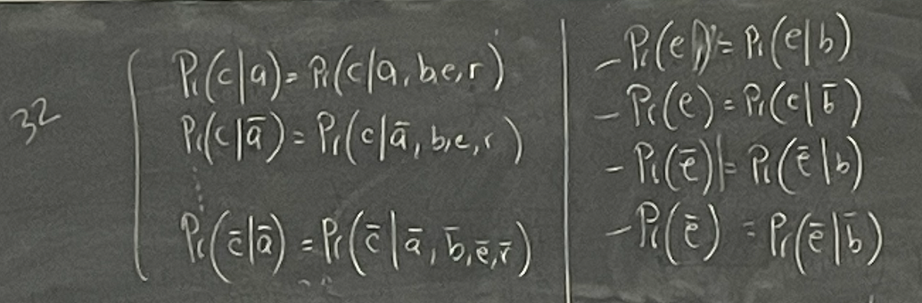

**Parameterizing the Structure**

Here is our causal graph/network

We want to parameterize the graph:

**Conditional Probability Table (CPT)**

| A C | P(C | A) |
| --- | --- |
| a c | P(c | a) = 0.8 = θc|a |
| a not c | P(not c | a) = 0.2 = θnot c|a |
| not a c | P(c | not a) = 0.001 = θc|not a |
| not a not c | P(not c | not a) = 0.999 = θnot c | not a |

* θ ⇒ “Parameters”

Example:

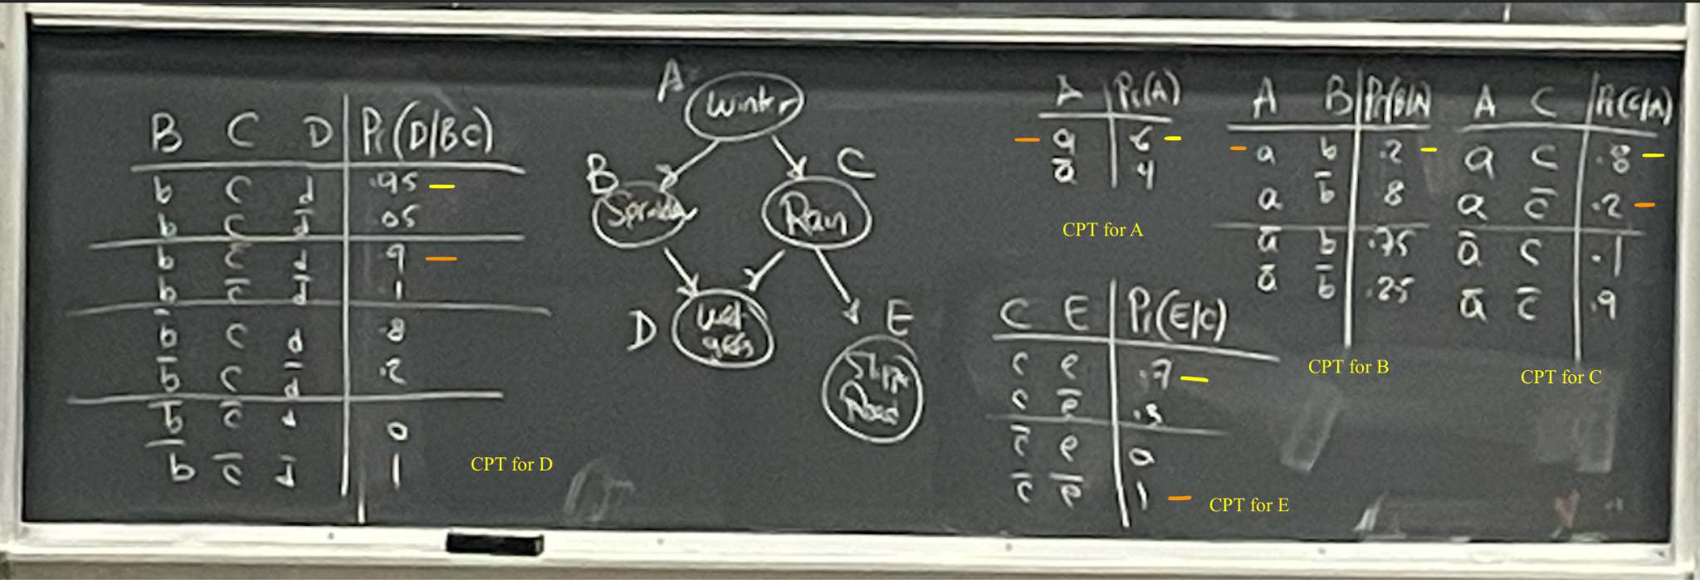

|  | A | B | C | D | E | P(A, B, C, D, E) |
| --- | --- | --- | --- | --- | --- | --- |
| w1 | a | b | c | d | e | 0.6 x 0.2 x 0.8 0.95 x 0.7 |
| w2 | a | b | not c | d | not e | 0.6 x 0.2 x 0.2 x 0.9 x 0.1 = 0.216 |
|  |  |  |  |  |  |  |
|  |  |  |  |  |  |  |
|  |  |  |  |  |  |  |
| w32 | not a | not b | not c | not d | not e |  |

Given our graph G

Markov(G):

* I (C, A, BER)
* I (R, E, ABC)
* I (A, BE, R)
* I (B, 𝜙, ER)
* I (E, 𝜙, B) = P(E | B) = P(E)
* I (B, 𝜙, E)? → not in the given markov set but it will still hold as per our graph
  + P(B | E) = P(B)

**d-deparation (d-Sep)**

* Determines if in a directed acyclic graph two set of nodes a d-separated by a third set of nodes.
* dsep(X, Z, Y) → X and Y d-separated by Z
* We look at the graph and get a yes or no answer → I (X, Z, Y)
  + TRUE if X and Y are d-separated by Z

# Week 8 Lec1

**Probability** is a basis for beliefs (foundation)

* Usually exponential in variables

**Bayesian Networks**

* Modeling tool
* Types:

Directed Acyclic Graph (DAG) : Causality

Number: Probability

**Inference**

* Compile bayesian networks into circuits

**Learning**

**Notation**

* Variable: Capital letter (X, Y, Z)
* Value: lowercase letters (x, y, z)
* Ex: If X: {r,b,g}
  + P(x): P(X = x)
  + P(X): distribution over X
* Set of variables: **X**
* Instantiations: **x**
* Ex: Z: {l, s, m} **A** = {X, Y} **a** : X = l, Y = s
* T : Binary variable
  + T is True: t
  + T is False: ŧ

**Variable Independence**

* 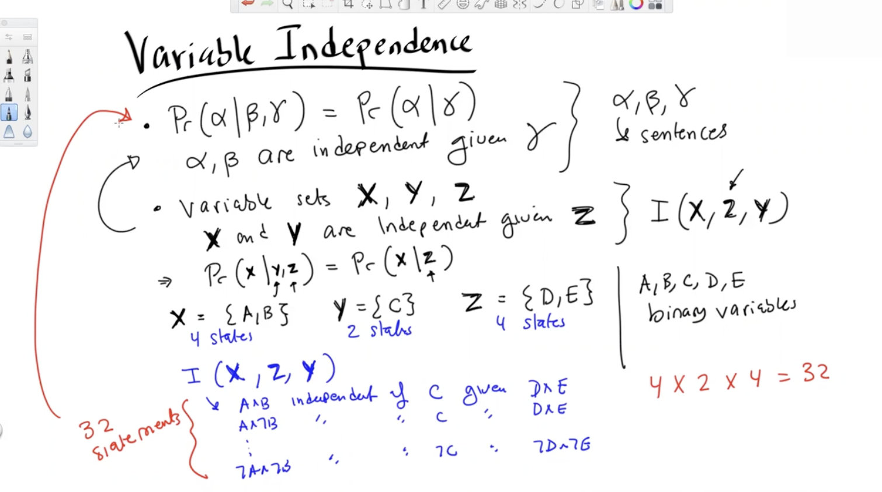

**Capturing Independence Graphically**

* 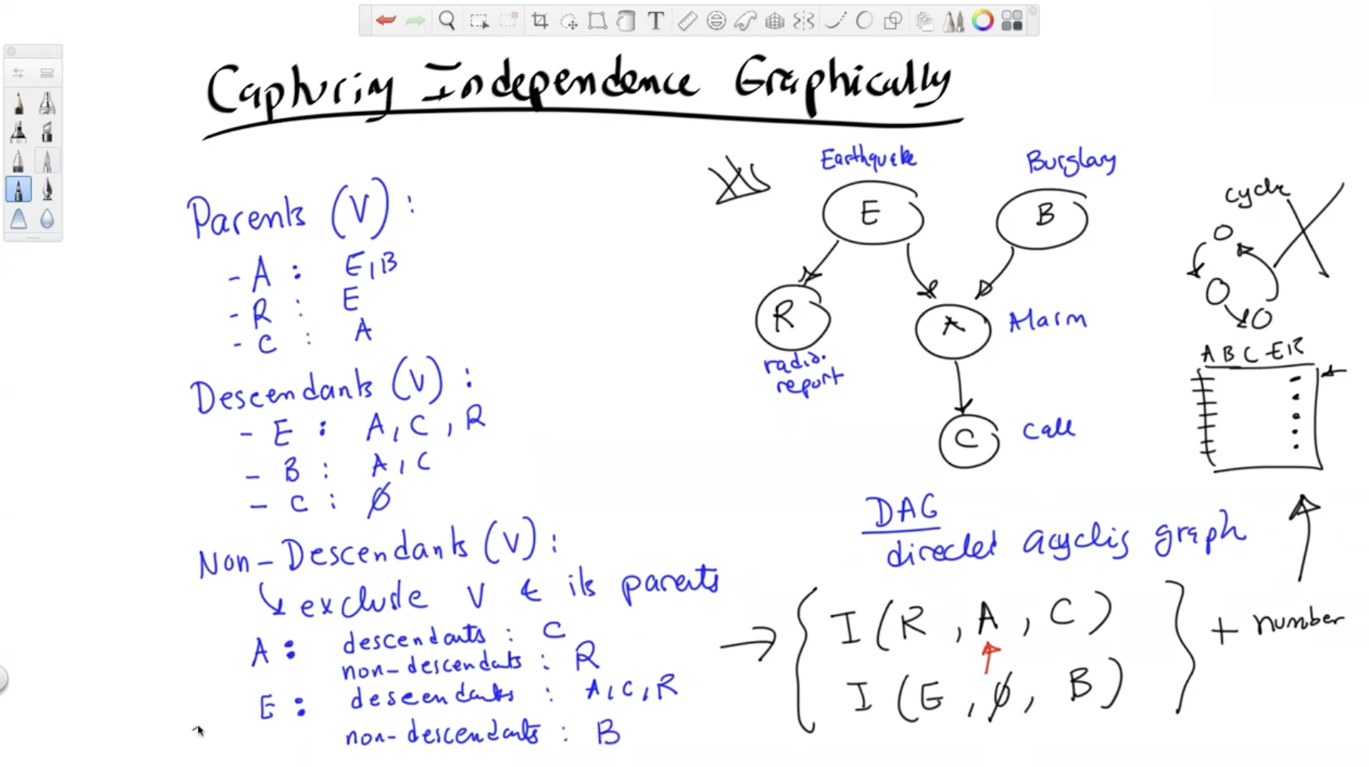

**Markovian Assumptions**

* All of the independent statements implied by a Bayesian Network.
* *I(V, Parents(V), Non-Descendendants(V))*
  + For every variable V, once you tell me what the parents are, I am not going to change my mind about the non-descendants

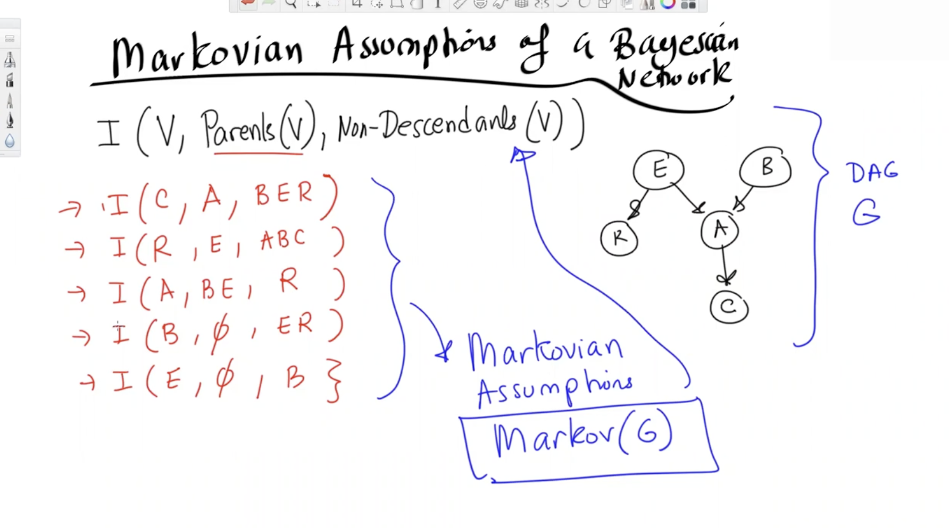

**Parametrizing the Structure**

* Notice that I have two probability distributions, one when A = True, and one when A = False  
  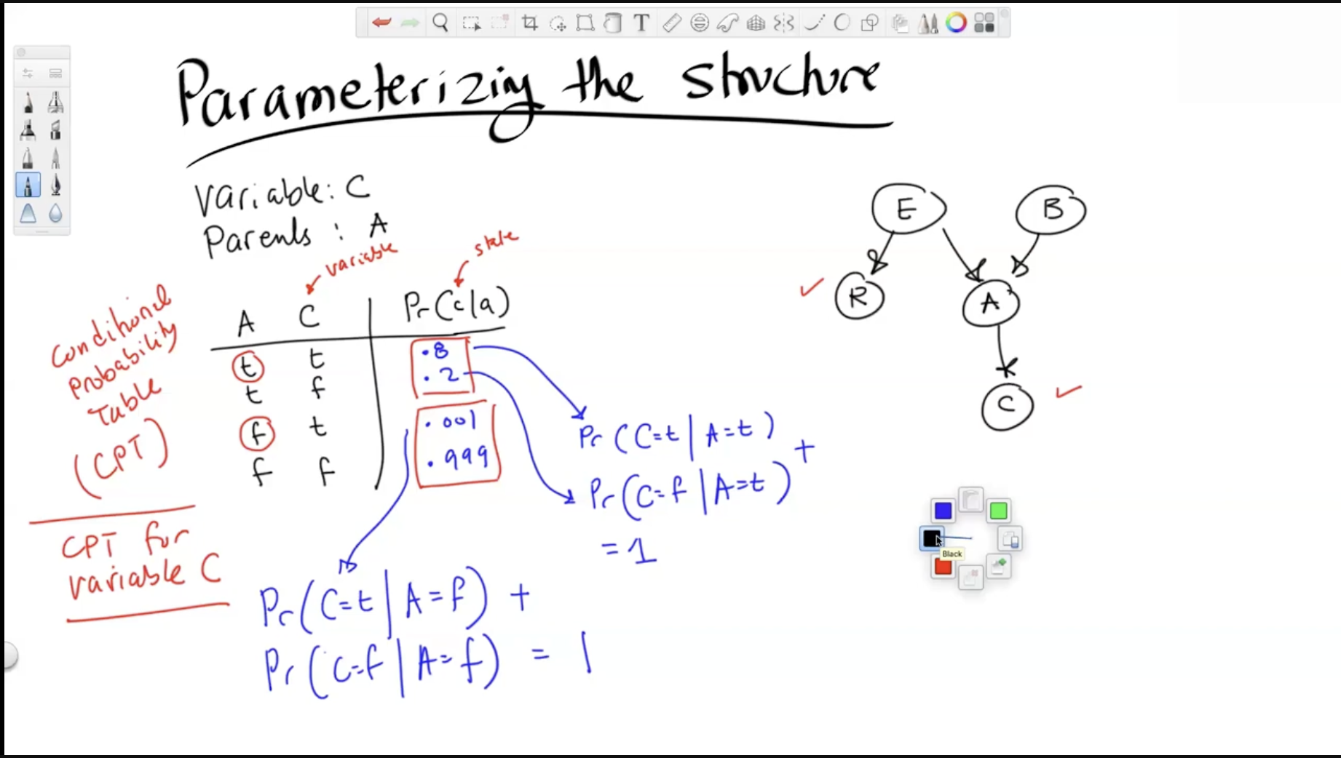
  + Here I have 4 parameters (weights) but only 2 are independent
* If I were to draw the CPT for A, it would be larger, as it has two variables on which it depends, E and B

. 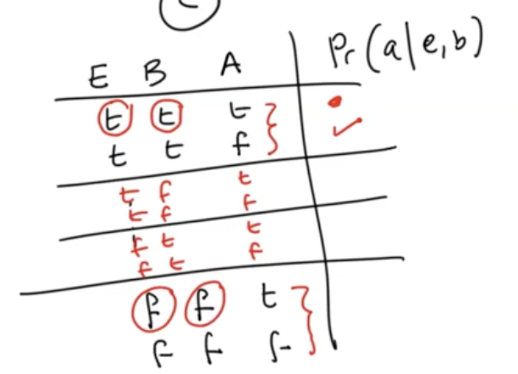

* + This would have 4 distributions, like
    - E = T, B = T
    - E = T, B = F
    - E = F, B = T
    - E = F, B = F
  + In this table, I have 8 parameters (weights) but only 4 are independent
* The parameters are important in neural networks and can be learned based on data.

# Week 8 Lec 2

**Distribution of Bayesian Networks:**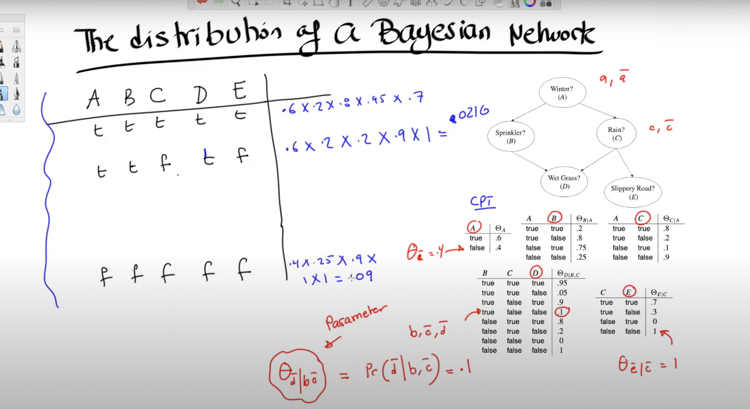

**D-seperation**

* If every path between x and y is blocked by z, then x and y are d-separated.   
  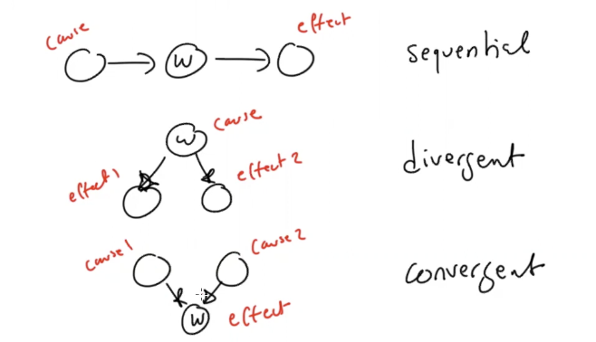

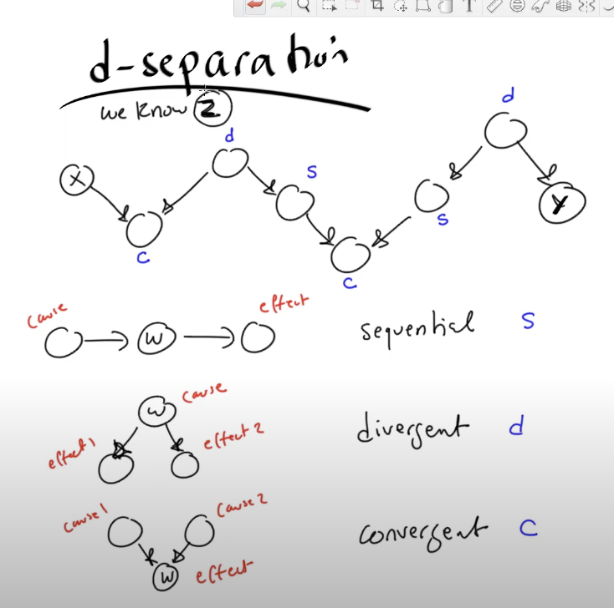

* The type of valve is determined by what path is being considered

**Conditions**

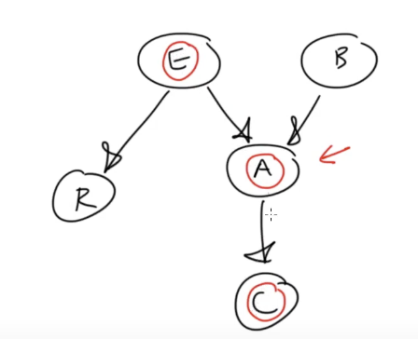

* **A sequential valve is closed iff variable w $∈ Z$. Here A is the variable w.**
* **A divergent valve is closed iff**  **variable w $∈ Z$. Here E is the variable w.**
* **A convergent valve is closed iff neither variable w nor any of its descendants are in $Z$**
* Example1:   
  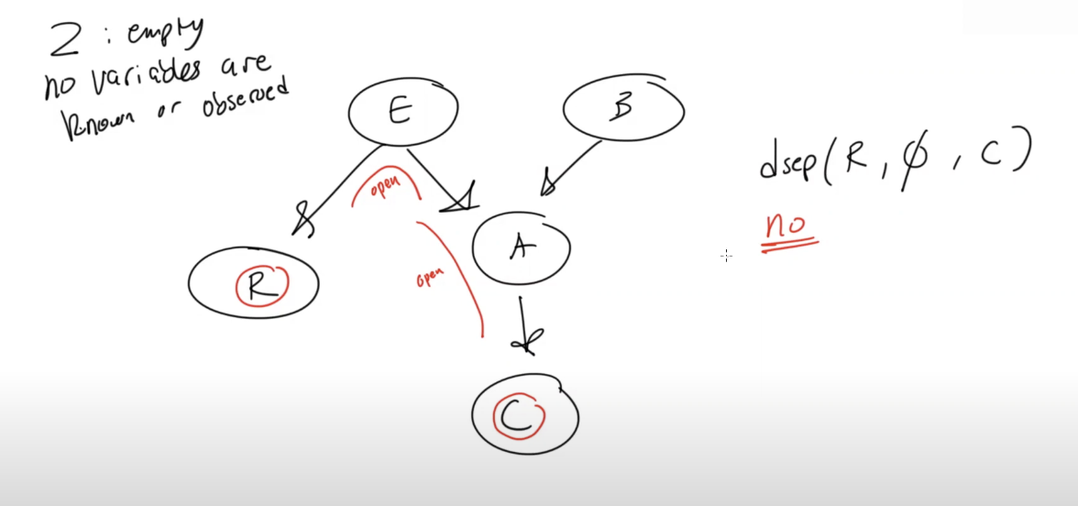
* Example2:   
  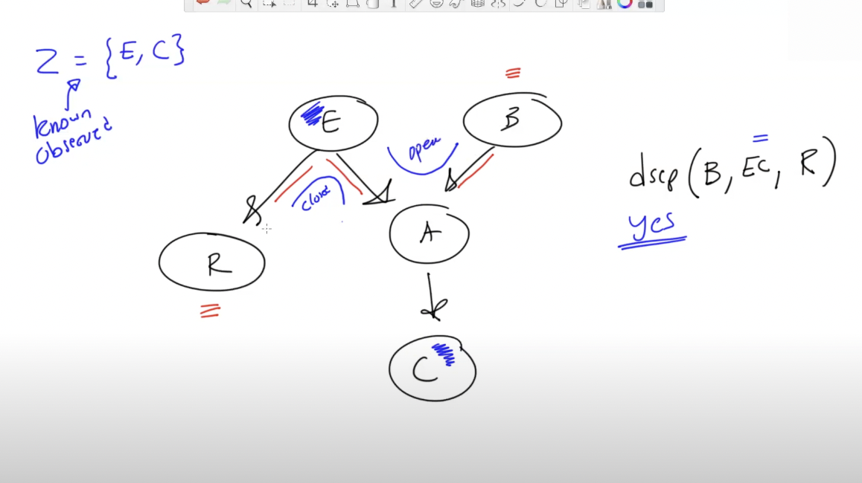
* Example 3:

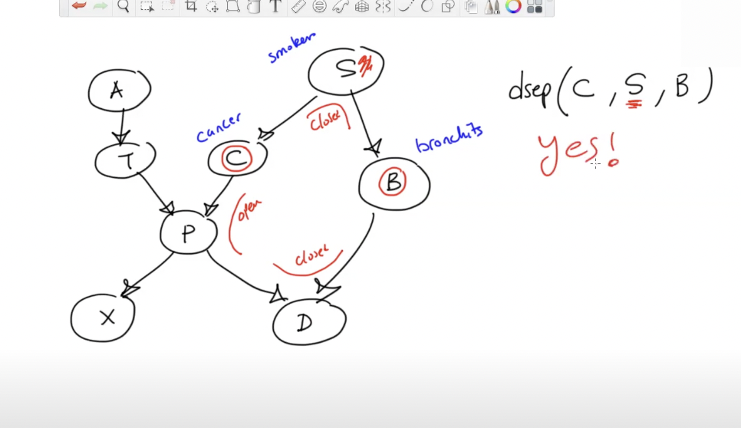

# Week 9 Lec 1

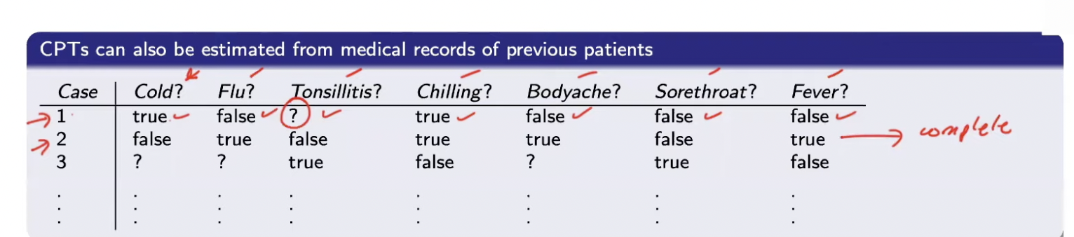

* Complete → closed form
* Incomplete → EM: Expectation Maximization

BN structure + CPTs = Bayesian Network

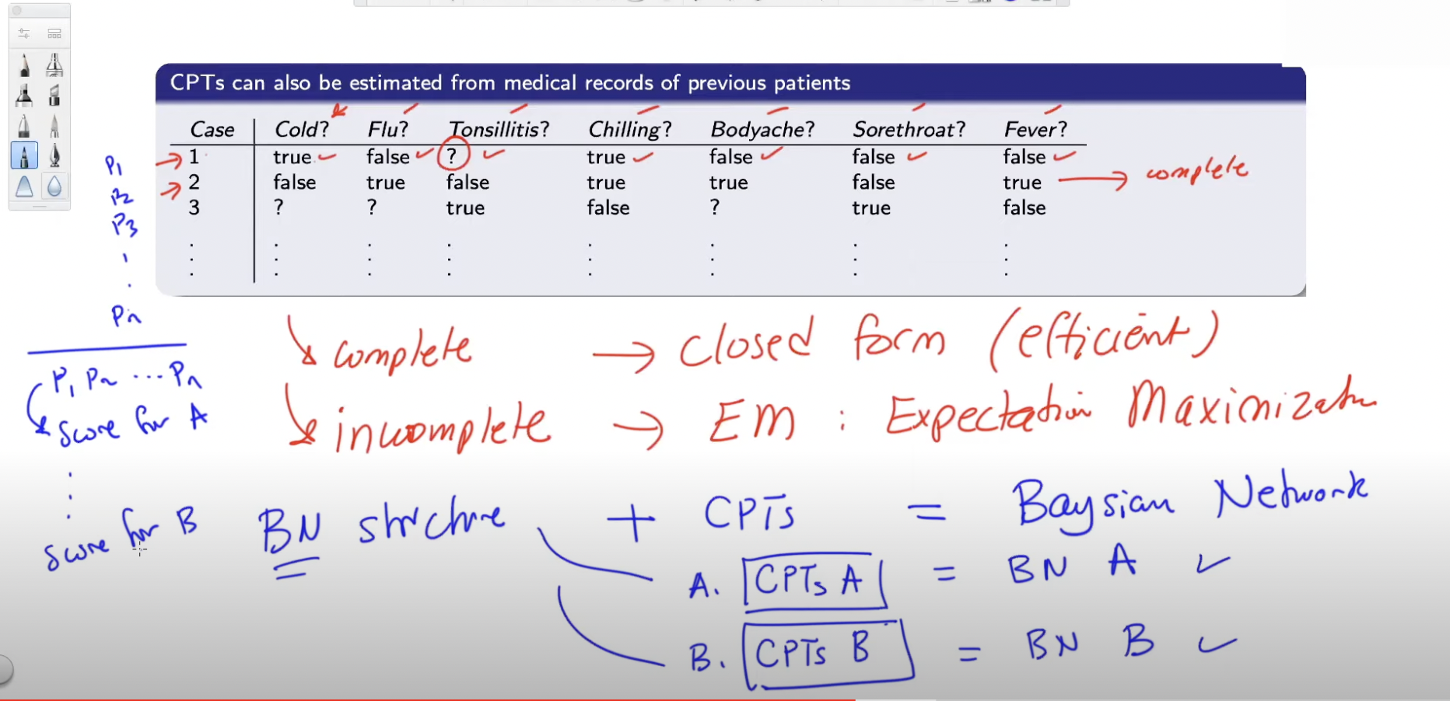

We will take the probability where we have the maximum. Maximum likelihood principle.

Prior Marginal: Probability of some event without having any evidence

Posterior marginal

- When you have evidence

- "I have someone who tested positive for both T1 and T2, what is the

probability they have the condition?"